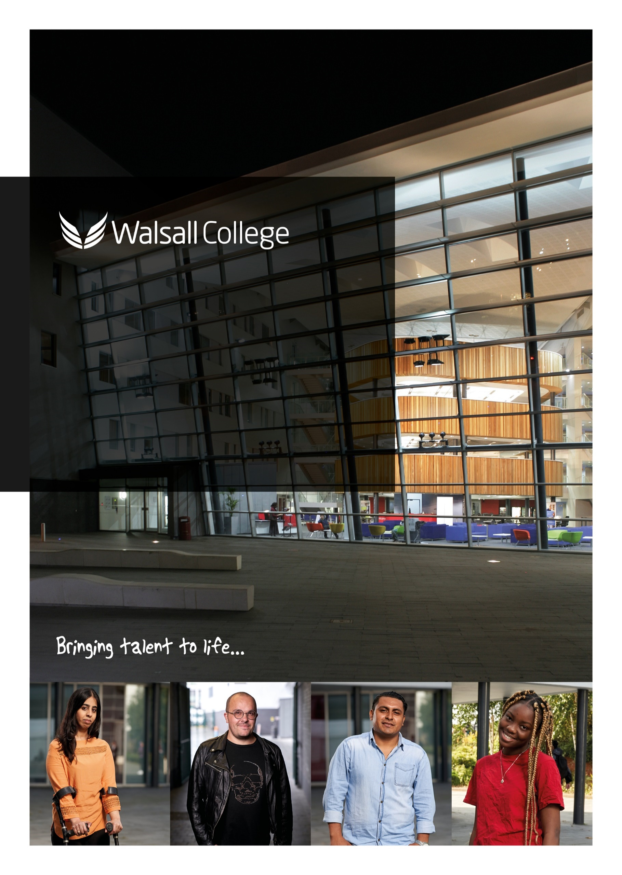

|  |  |
| --- | --- |
| DEPARTMENT | Contracts and Compliance |
| DATE ISSUED | November 2021 |
| REVIEW DATE | August 2026 |
| Version | V6 |

**Policy and Procedure**

**Freedom of Information Policy**

**To request a copy of this document in an alternative format such as   
large print, please contact 01922 657000.**

**Contents**

1. Purpose 0

2. Scope 0

3. Responsibility 0

4. Policy 0

5. Procedure 0

6. Documentation 0

7. Related Policies and Procedures 0

8. Definitions 0

# Summary of Changes

| **Section/Page** | **Description** | **Rationale** |
| --- | --- | --- |
|  |  |  |
| Page 3 | Removed Pioneer House and added The Link | Change of campuses. |
| Page 4 (2.2) | Review of Publication Scheme included | For transparency and openness |
| Page 4 (3) | Added section about IAR | To remind staff where to search for information. |
| Page 5 | Deletion of words | Not required |
| Page 6 (6) | Exemptions | Compliance with the FOIA |
| Page 6 (7) | Training | To confirm that training takes place |
| Page 6 (8) | Retention | Compliance with FOIA and Retention Schedule |
| Page 7 | Added to Complaints Procedure | To enhance the complaints procedure |

# Purpose

Walsall College is committed to the highest standard of teaching and learning, across a full range of vocational and academic activities. The College currently incorporates ten sites – Wisemore Campus (main), The Hub, Broadway, Portland Street, Green Lane, Hawbush and Whitehall campuses, Pleck Library, The Link, and Construction College Midlands.

This policy describes the ways in which the College is complying with the Freedom of Information Act 2000 (hereafter referred to as the FOIA). This includes how staff, students and members of the public can exercise their rights, and the responsibilities of the College and its members, under the FOIA.

The FOIA establishes a “general right of access to all types of recorded information held by public authorities” and operates in conjunction with the Data Protection Act (DPA) 2018 and the Environmental Information Regulations Act 2004 (EIR), with oversight of all three resting with the Information Commissioner (ICO). When the College receives requests they will be handled under the appropriate legislation.

This legislation and regulation promote a “culture of openness” and accountability, alongside protecting privacy rights, across the public sector. As such, they encourage proactive publication of information and on-going development of good records management, as well as governing access to information held by public authorities.

Compliance with the legislation includes adoption of a “Publication Scheme”, described below, as well as ensuring information requests are handled appropriately according to the relevant legislation. It also requires the College to manage information and records appropriately, as addressed by other policies.

# Policy

**2.1 The Publication Scheme**

The initial requirement of the FOIA is adoption of a “Publication Scheme”. The College’s updated Publication Scheme is available on the College’s external website.

**2.2 What is a “Publication Scheme”?**

A Publication Scheme is a document which describes the information a public authority publishes, or intends to publish. In this context, ‘publish’ means to make information available, routinely. These descriptions are called ‘classes of information’. The scheme is not a list of the actual publications, because this will change as new material is published or existing material revised. It is, however, the College’s commitmentto make available the information described.

The Publication Scheme sets out the classes, or categories, of information published. It also makes clear how the information described can be accessed and whether or not charges will be made.

Walsall College has adopted the model Publication Scheme developed for the Further Education sector and is therefore, committed to publishing the information it describes.

This model is designed for Colleges across England, Wales and Northern Ireland. The purpose of the model is to save institutions duplicating effort in producing individual schemes and to assist the public in accessing information from across the sector. However, to reflect the diversity in size and function of the institution, a number of optional classes of information are included. As a result, models within the sector will vary slightly. Any optional classes relevant to Walsall College have been included in our scheme.

The College is legally committed to publishing according to the scheme, and to developing (and so extending the information covered by) the scheme. As well as complying with the FOIA, this should be of benefit to the College, since it should enable easier location and access to the College’s information - for members of the College as well as members of the public.

The Data Protection Team will administer continued development of the College’s Publication Scheme, to provide navigation to as much College information as possible. Those producing [non-ephemeral] College information, for which there is no reason to retain confidentiality, should ensure their output is referred to the Data Protection Team for appropriate inclusion in the Publication Scheme.

The Publication Scheme is reviewed annually by the Data Protection team to ensure that it remain accurate, up to date, and reflective of the information most frequently requested. Where appropriate, the College will identify and publish additional materials that are commonly requested, to reduce the need for individual FOI requests and support a culture of openness.

# Accessing Information Covered by the Publication Scheme

The scheme describes classes of information we publish. Next to each class we have indicated the manner in which the information described will be available, including links to web information and contacts to access other formats. We have also indicated whether charges apply to material in each class.

To request information available through our publication scheme, use the form provided below.

It is important that the scheme meets the needs of information seekers - both internal and external to the College, as well as meeting legal compliance. Consequently, feedback is crucial.

If you find the scheme difficult to understand or to access in its existing format, please let us know. We also welcome suggestions as to how our scheme might be improved. Any questions, comments or complaints about this scheme should be sent in writing to the contact details below.

The College maintains a comprehensive Information Asset Register (IAR) to support the effective handling of Freedom of Information requests. The IAR provides a structured overview of the types of information held across the organisation, their formats, responsible owners, and retention schedules. This enables staff to quickly identify where the requested information is held, who is accountable for it, and how it should be accessed or assessed for disclosure. The IAR is regularly reviewed and updated by Information Asset Administrators in collaboration with the Data protection team to ensure that it remains accurate and fit for purpose.

**3.1 Requests for information not covered by the Publication Scheme**

Given “the natural place of a College as an open information provider”, we are used to receiving and responding to enquiries for information. In most cases, we will follow our usual practice of fulfilling requests made to the relevant department holding the information. We will also continue development of the College’s Publication Scheme to provide navigation to as much available College information as possible.

Under the FOIA, you have the right to request any information held by the College which it has not already made available through its Publication Scheme. Enquiries should be made to:

The Data Protection Officer

Walsall College

Wisemore Campus

Littleton Street West

Walsall

WS2 8ES

[dataprotection@walsallcollege.ac.uk](mailto:dataprotection@walsallcollege.ac.uk)

# Making and Receiving Requests

Requests do not have to mention FOIA but have to be made in writing. Requests made under the EIR can also be made verbally.

This means any enquiry requesting information not included in our Publication Scheme is essentially a request under FOIA or the EIR. As such, the College is obliged to provide the information within 20 working days. We may charge a fee. We will not be required to release information to which an exemption in the Act / Regulations legitimately applies. However, we are required to explain to the applicant why we are not releasing information and we may also have to justify this to the Information Commissioner.

Where information is known, and open, it should be provided directly, especially where a l department is familiar with providing such information. However, if information is not readily available, or where there is the potential of applying FOIA / EIR exemptions and not providing all the requested information, the request should be assessed to ensure it is handled under the appropriate legislation to govern release of the information. The Data Protection Team may also consider the ‘cost of compliance’ which will take account of the likely cost of:

* determining whether the information is held by the College
* finding the requested information, or records containing the information;
* retrieving the information or records; and
* extracting the requested information from records.

The team will also administer the logging of requests and communication with the applicant, including any appeals or complaints. In handling requests, staff will work with the applicant, appropriate departments and College managers

# Costs for Information Requests

In most cases we will endeavour to provide information electronically and will not charge. In cases where it is more appropriate to provide information in other formats, we may charge to cover disbursement costs such as printing and postage.

If the estimated ‘cost of compliance’ exceeds reasonable limits (as set by the Fees Regulations, currently £450 or about 2.5 days of staff time[1]), we will refer to the applicant and attempt to refine the request so as to reduce the potential retrieval costs. Where this is not possible, we may refuse to meet the request, or we may charge disbursement costs. In this instance, we will issue a bill, based on our estimate of costs, and we will respond to the request after payment of the amount.

# 6. Exemptions

Whilst the College promotes transparency and openness, there are certain types of information that may be exempt from closure. Exemptions apply when releasing the information would conflict with other public interests, legal obligations, or individual rights. These include, but not limited to, personal data, national security, commercial interests, law enforcement, or legal privilege.

Exemptions may either be absolute (where information cannot be disclosed under any circumstances), or qualified (where the College must consider whether the public interest in withholding the information outweighs the interest in disclosure). When an exemption is applied, the College will provide the requester with a clear explanation, including the legal basis for withholding the information.

# 7 Training

We are committed to ensuring that all relevant staff understand their responsibilities under the Freedom of Information Act 2000. Staff involved in handling requests or managing records will receive annual training to maintain their awareness of FOI obligations, procedures, and best practices. This includes identifying valid requests, understanding applicable exemptions, and responding within statutory deadlines.

# 8 Retention of FOI Requests

All Freedom of Information requests, including related correspondence, responses, and any internal assessment or decisions, will be retained by the College for a period of six years from the date of the final response. This retention period supports accountability, allows for internal reviews or investigations and ensures compliance with audit and legal obligations. After the retention period the records will be destroyed securely in line with the College’s Retention Schedule.

**9 Complaints**

In the case of a complaint, in the first instance, details should be reported in writing to the College’s Data Protection Officer at the address below:

The Data Protection Officer

Walsall College

Wisemore Campus

Littleton Street West

Walsall

WS2 8ES

Or email dataprotection@walsallcollege.ac.uk.

If the matter cannot be resolved by the Data Protection Officer, the complaint will be referred to a Complaints Panel, consisting of senior College Officers and Governors. Requesters have a right to an internal review within 40 working from the College’s response. The internal review will reassess the handling of the original request, including whether the appropriate exemptions were applied and whether the response complied with the requirement of the Freedom of Information Act.

If we are unable to resolve any complaint, you can complain to the Information Commissioner, the independent body who oversees the Freedom of Information Act 2000:

Information Commissioner

Wycliffe House

Water Lane

Wilmslow

SK9 5AF

**0303 123 1113**

**5.2 Further information**

More information about the Freedom of Information Act 2000 is available on the Information Commissioner’s website at: <http://www.ico.org.uk/>

1. 1 These cover the specific costs ceiling for requests. This is an important exemption to the general right stated earlier in the Policy but please be aware that there are draft regulations that have recently been put forward by the Government that may change this ceiling in the future.