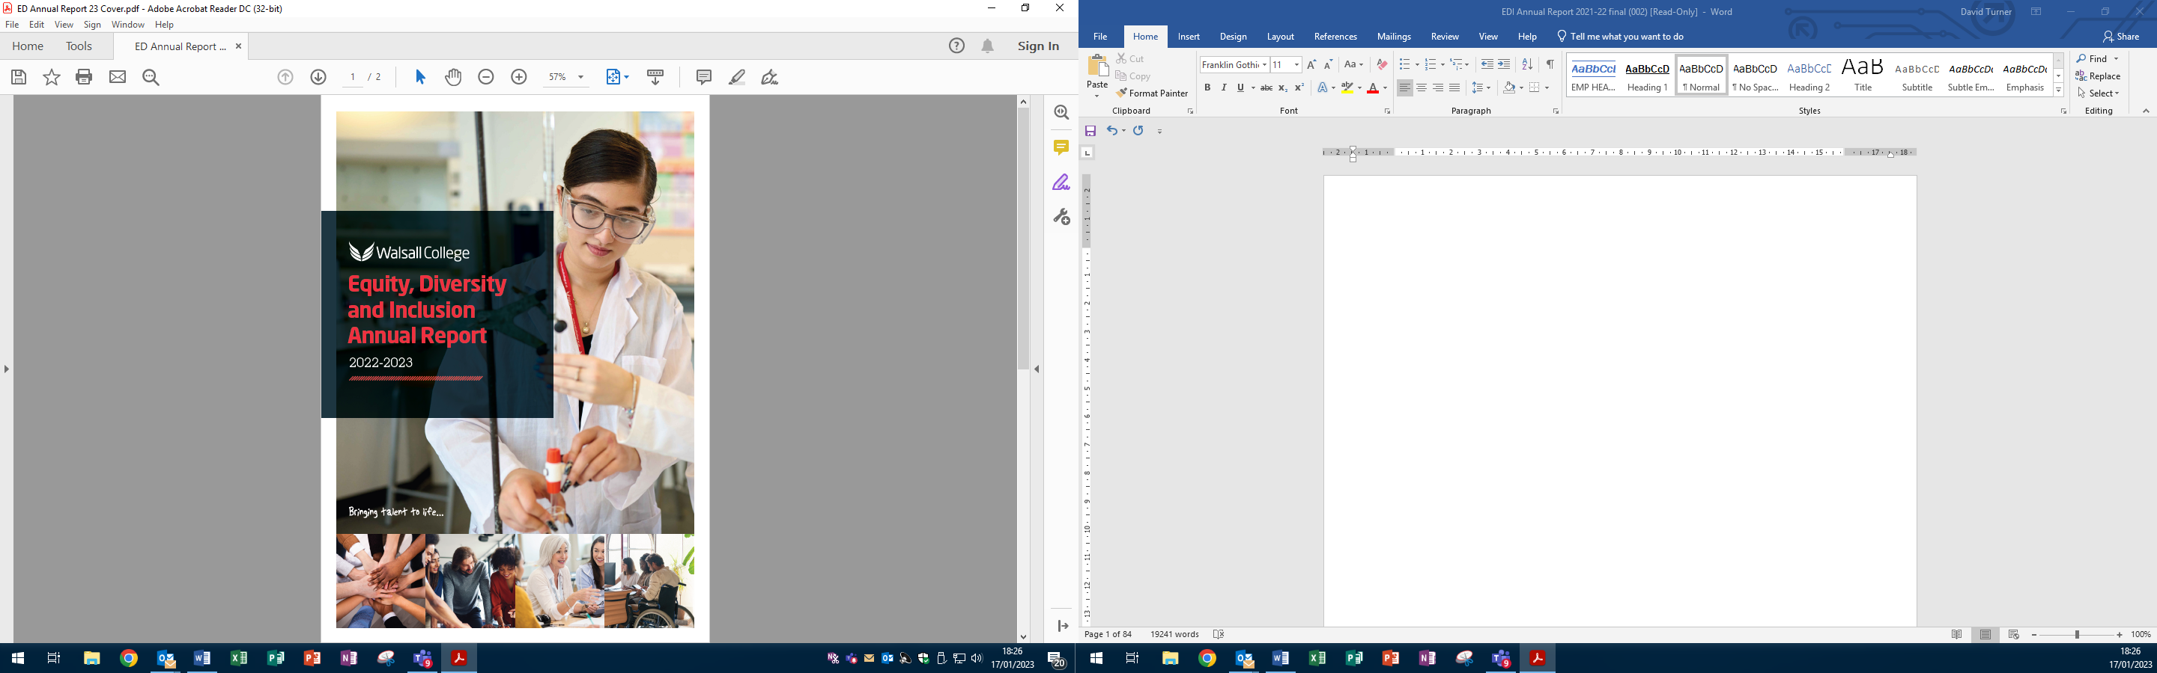

**OUR COMMITMENT**

As we continue to transition through the 2020s, our vision to provide students with an excellent learning experience, training, education and skills development to support them into higher levels of study and jobs, is more than ever a priority for our College community. The College embodies Positive Communities and British Values and this is recognised by all those with whom we work. Students, staff and stakeholders recognise the inclusive nature of the College ethos and understand our expectations for equity, diversity and inclusion as are embedded in our **College Mission**:

*“Walsall College is uniquely and proudly vocational, delivering technical, professional*

*and community education. Our greatest passion is unleashing the potential of individuals, communities and businesses; our greatest legacy is the talent of our students: skilled, professional and enterprising.”*

Our experience of the COVID 19 pandemic, both from an educational establishment and teaching and learning perspective resulted in a need to acknowledge the continuous after effects of lockdown which are still prevalent but slowly easing. However, our ongoing vigilance and the need to respond towards supporting the mental health of both staff and students is ongoing. Constant evaluation of the specific needs of our student cohort contributes to our being able to ensure that we are responding appropriately and effectively. Therefore, our values are ever more important in facilitating the journey as are our commitments and actions to ensure that the student is at the heart of everything we do:

Our intent to ensure that our student community has a legal right to teaching that does not discriminate them on the grounds of the protected characteristics;

That students who require support to access education are supported through reasonable adjustment and support mechanisms;

That we adopt, apply and embed our mission to bring talent to life through the variety of vocational, technical, professional and community education;

That we drive to implement our shared values – passion, integrity, innovation, equity, collaboration and sustainability.

Our commitment to equity, diversity and inclusion continues to be evident in **Our Vision** outlined within our **Corporate Strategy 2021-2024**. We will provide all students, regardless of their sex, race, ethnic origin, disability, sexual orientation, religion or belief, marital status or age, an “excellent learning experience, education and skills development to support them into higher levels of study and jobs”.

Walsall College is passionate about helping students to achieve positive outcomes whether that is to get back into work, start a new career or climb the career ladder. To support this, we offer a broad and varied curriculum from entry level through to higher education, apprenticeships, T-Levels, top-up degrees and professional level qualifications all of which are designed to give our students the skills employers want to meet local, regional or national demand.

**Our Shared Values** remind everyone in the organisation (staff and students) as well as our stakeholders,

that we work to a straightforward set of principles which underpin both our mission, and vision:

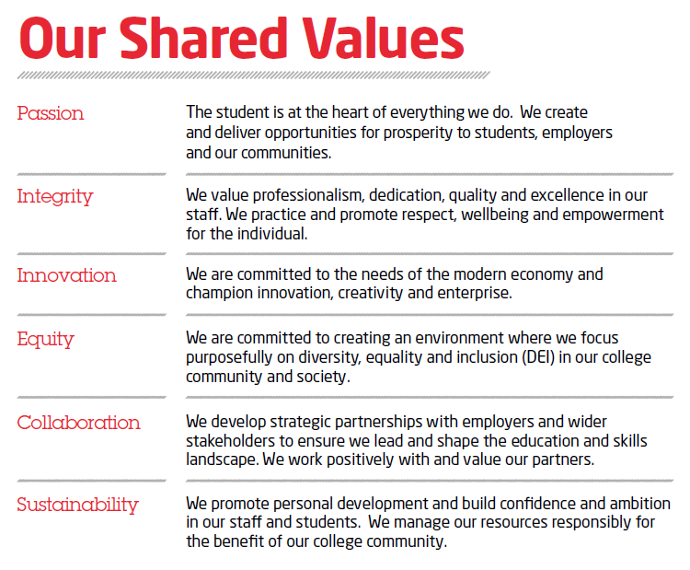

**Population of Walsall**

Whilst we have seen some improvements in the overall local and regional economy when compared to previous years, the context remains extremely challenging, with a clear need for Walsall College to continue to provide opportunities for high quality education and training which will not only ultimately improve the local and regional prosperity, but also the prospects of residents in terms of lifestyles, health and wellbeing and social mobility.

Walsall has an estimated population of 284,124 (2021 Census), comprised of approximately 21.7% children under 15, 60.8% working-aged 16-64, and 17.5% 65+ over giving a dependency ratio of 0.64 dependents to every 1 working age adult. Female residents represent 51.2%.

Walsall is expected to see continued & consistent population growth, projected to **increase by 7%** to an estimated **304,400 by 2030** & further by 13% to an estimated 320,400 by 2040 (2020 ONS, 2018-based projections). The largest increases are expected within older age groups; the population over 65 years of age will increase their share of the population from approximately 18% to 20% by 2040 (around a 1% decline in population share for both children & working-age adults). There has already been an 8.8% increase in births in Walsall between 2004 and 2014, and the number of Walsall of reception pupils in Walsall schools has increased 11.34% between 2012 and 2017.

Walsall’s economy has an annual output of £4.77 billion and provides around 120,000 jobs however, only two thirds of working age residents are in employment and for those in work, earnings are below the national average.

**Ethnicity**

Walsall is a net importer of people both nationally and globally and, therefore, the Borough of Walsall has a diverse population, which varies greatly in each ward. There are around 75 community languages spoken. Walsall is a culturally diverse town where people of Indian, Pakistani and Bangladeshi background form the largest minority ethnic groups. White British comprise the largest ethnic group at approximately 67.4% of the borough population, and more broadly the wider White ethnic category at 71.4%. Total minority ethnic groups have seen substantial increases, now accounting for almost 30% (1 in 3) of Walsall's population, compared to 23.1% (1 in 4) a decade prior in 2011.

|  |  |  |
| --- | --- | --- |
| **Ethnic group** | **Percentage** | **Number** |
| Total: All usual residents | 100.0% | 284,126 |
| Asian, Asian British or Asian Welsh | 18.7% | 53,199 |
| Black, Black British, Black Welsh, Caribbean or African | 4.6% | 13,024 |
| Mixed or Multiple ethnic groups | 3.3% | 9,317 |
| Other ethnic group | 2.1% | 5,862 |
| White | 71.4% | 202,724 |
| **Total ethnic groups** | **28.6%** | **365,528** |

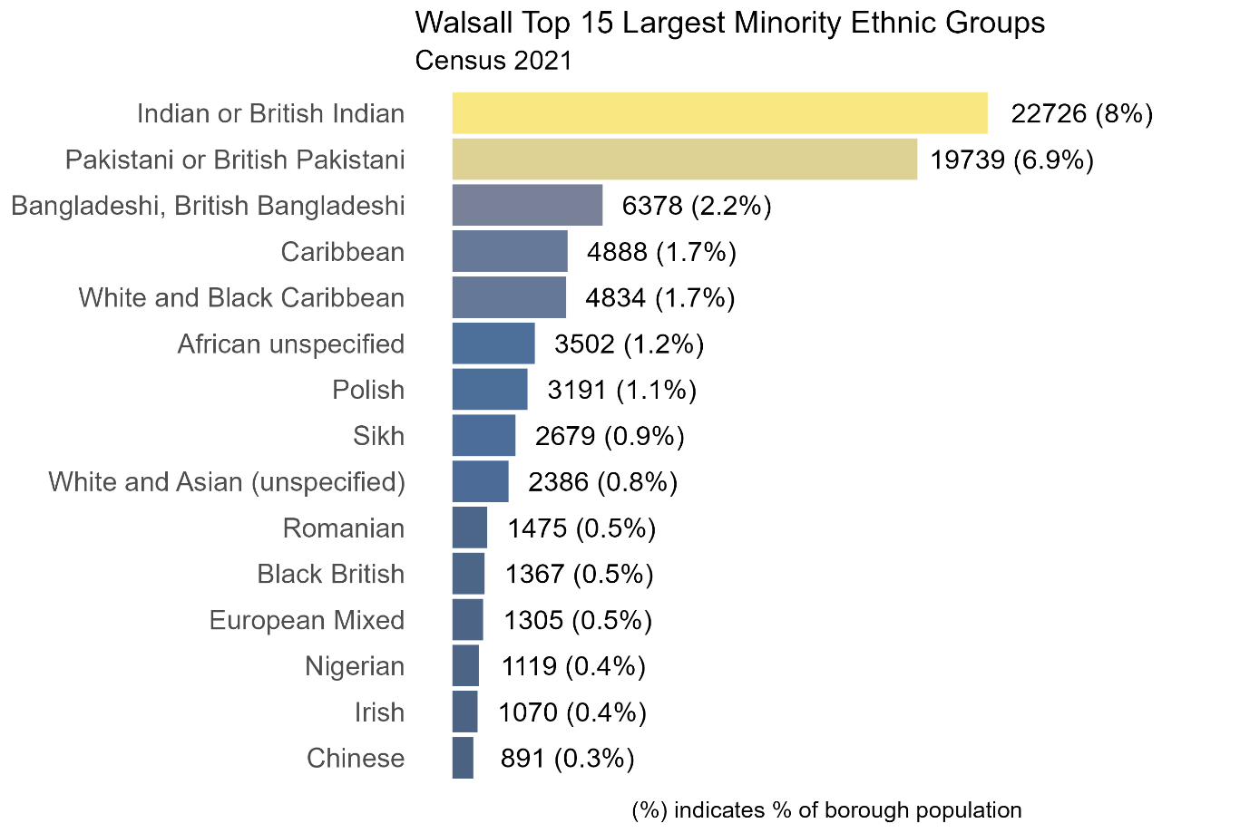

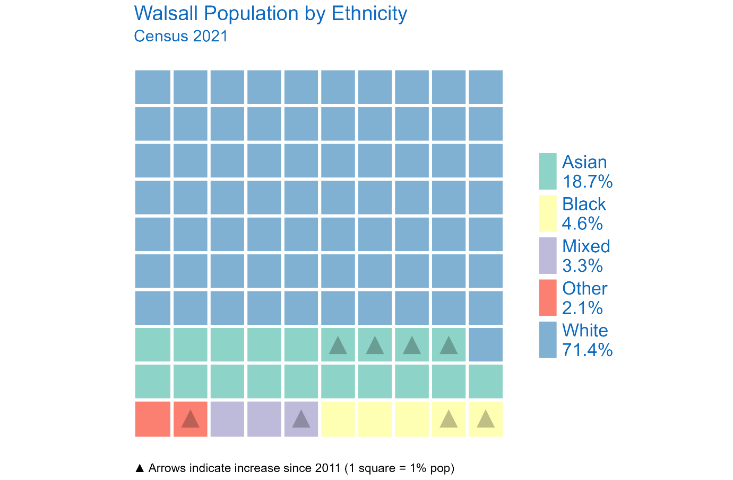

**Mental Health and Wellbeing**

The World Health organisation states that: “Mental health is a state of well-being in which the individual realises his or her own abilities, can cope with the normal stresses of life, can work productively and fruitfully, and is able to make a contribution to his or her community.” (WHO, 2001).

It is vital that Walsall College plays its part in supporting good mental health for its students. If mental illness has a significant, adverse and long-term effect on someone’s ability to carry out normal day-to-day activities, it is likely they are protected under disability discrimination law. This includes people who had a disability in the past. The law considers the effects of an impairment on the individual. For example, someone with a mild form of depression with minor effects may not be covered. However, someone with severe depression with significant effects on their daily life is likely to be considered as having a disability.

Mental wellbeing is also fundamental for feeling included and in being able to maximise the benefits and opportunities found within a supportive and nurturing learning environment. It is important to note however, that a person living with a mental illness can achieve positive mental wellbeing, like someone who has neither mental nor physical illnesses.

Along with many other local and regional partnership groups, Walsall College is a stakeholder/contributor to Walsall’s Multi-Agency Mental Wellbeing Placed Based Strategy “Together We Can” 2022- 2032. This excellent

strategy clearly highlights how our diverse borough has a strong sense of local identity that celebrates diverse backgrounds which contributes positively to the mental health and wellbeing of residents, however, despite this, on average Walsall residents overall experience higher levels of mental ill-health and lower levels of mental wellbeing than the England average.

A contributory factor for poor mental health and wellbeing in Walsall is that it has a high level of multiple deprivations. Walsall is ranked the 25th most deprived Local Authority area in England (out of 317). Around half of Walsall residents live in the most deprived 20% of neighbourhoods in England and the rate of unemployment in our borough also falls within the worst 20%. There has been a sharp increase in unemployment claims throughout the COVID-19 pandemic, which has disproportionately affected our younger people. Deprivation and unemployment are strongly and consistently linked to low levels of wellbeing, and higher rates of depression, anxiety and suicide.

Throughout the COVID-19 pandemic in the UK, people of “other than white” ethnicity have experienced lower life satisfaction than the white population, whilst simultaneously having a higher loneliness score. At the same time, people in minority ethnic communities are less likely to receive medication, counselling or therapy for mental ill-health.

Even prior to the pandemic, there were entrenched and persistent health inequalities in our region. On average people in the West Midlands Combined Authority (WMCA) have a shorter life expectancy than England overall, and spend more of their lives in poor health. Women live for 82.2 years on average (England 83.2) and spend 22 years in poor health, men live for 78 years on average (England 79.6) and spend 18 years in poor health.

Most areas in the WMCA have a greater level of socioeconomic deprivation than the national average, with approximately a quarter of children living in low income households. Gross Disposal Household Income (GDHI) per person in 2017 was £16,479 compared with £19,514 in the UK as a whole.

The lives of many people in the WMCA are hard, and unhealthy behaviours are often coping mechanisms for people who live in challenging circumstances, or reflect the limitations of the environments they live in. Often people want to make positive changes to improve their health, such as being more active or giving up smoking, but are not supported to do so and feel powerless to make positive change.

In line with national findings, the pandemic has exposed and exacerbated existing health inequalities. The WMCA has a higher rate of cases overall than the region as a whole, with Birmingham and Sandwell most affected; rates are also high in Solihull, Walsall and Wolverhampton. The highest rates of COVID-19 related deaths are in more deprived areas, and areas with a greater proportion of residents from BAME communities.

Lockdown and social distancing measures have had direct impacts on wellbeing and on health behaviours. Anxiety has increased significantly in the West Midlands region, with almost half of people surveyed (47.9%) reporting high levels of anxiety compared to a 2019 average of 21.9%. On average, people reporting feeling ‘often lonely’ ranged from 4.9% to 6.5% over this period; and was generally higher for younger people.

**Indices of Multiple Deprivation**

The English Indices of Deprivation (IMD), produced by the Department for Communities and Local Government (DCLG), provide a relative measure of deprivation in small areas of England. They are based on the concept that deprivation consists of more than poverty; so, whilst poverty is related to not having enough money to live on, deprivation refers to a much broader lack of resources and opportunities.

The indices are based on seven different domains (or aspects) of deprivation. They are distinct domains, each with their own score and ranks – and people may be counted as deprived in one or more of the domains depending on the types of deprivation that they experience. There are 39 separate indicators in total and each one is based on the most recently available time point. In addition to these seven domain-level indices, there are two supplementary indices; the Income Deprivation Affecting Children Index (IDACI) and the Income Deprivation Affecting Older People Index (IDAOPI).

* Income deprivation (weighted 22.5%)
* Employment deprivation (weighted 22.5%)
* Education deprivation (weighted 13.5%)
* Health deprivation (weighted 13.5%)
* Crime (weighted 9.3%)
* Barriers to housing and services (weighted 9.3%)
* Living environment deprivation (weighted 9.3%)

Walsall is an area of high economic and social deprivation with low skills and a low-income economy, which is evident in the average salary statistics. Full time workers resident in Walsall earn a gross weekly pay of £548.20 compared to £581.80 West Midlands compared to £613.10 Great Britain.

Female full-time workers resident in Walsall earn an average of £491.20 gross per week compared to £550.80 (WM) and £587 (GB). This is £100 less per week compared to male workers and there is a similar trend for part-time hourly paid workers. As at November 2021 6.8% of people are claiming out-of-work benefits compared to 5.7% (WM) and 4.6% (GB). The percentage of 18 to 21-year-olds claiming out-of-work benefit is the highest of all age groups at 10.8%, higher than 7.1% (WM) and 5.8% (GB) (Walsall Labour Market Profile 2020-21).

**Qualification Profile – Walsall residents with no qualifications**

The College has an important role to play in improving the skills level for residents within Walsall. The proportion of people holding a Level 4 and above qualification in Walsall has improved in recent years from 24.3% in 2015 to 27.6%, but this is still 12.7% lower than the 40.3% total for GB.

Similarly, the percentage of people with no qualification has fallen from 16.7% in 2015 to 9.2% but remains higher than in the West Midlands (8.3%) and Great Britain as a whole (6.4%).

**Walsall College Students**

Walsall College attracts people from all walks of life and socio-economic backgrounds. We have a diverse student population which demonstrates the impact of our inclusive approach to education. The data in this report relates to all students. Most of our students each year (circa 64 - 68%) derive from areas across the borough of considerable and extreme levels of deprivation (so called ‘Widening Participation’ post codes). The College believes passionately that any potential disadvantage should not be an absolute barrier to success and that the work we do to support our students and our community is having a positive impact on their lives and opportunities. The College student community comprises of circa 37% of students from a minority ethnic background which is reflected well in the latest regional figure of 32.6% (up 7.2% in the latest census data).

Later in this report we publish the retention data and achievement data for our students, reviewing this for age group, ethnicity, disability, learning difficulty and widening participation. If there is a material gap for a group of students above 3% then this is classified as material and informs an EDI Quality Objective for the following year to address.

**Partnerships & External Agencies**

The College promotes and values strategic partnership working with a range of external agencies which support aspects of our College community. We support the work of community organisations in both operational and strategic ways and we achieve this by having representation on a range of partnership boards. This includes the Adult and Children’s Safeguarding Partnerships, Walsall For All, the All Age Exploitation Sub Group, Safer Walsall Partnership, Violence Reduction Unit, PQA Adults and Children Join Subgroup, the Walsall Channel Panel and The PREVENT Delivery Group. There is representation at the Safer Student Black Country Group, and Locality Partnership and Practice Groups.

There are a number of initiatives in place and having a positive impact on the retention of our most at-risk students and we have been using the National Tutor (catch-up) Fund to support some of these interventions. We have also created additional posts to deploy as additional support for this agenda, contacting those where lack of attendance etc and holding small group and 1:1 mentoring session for vulnerable students. Working with Walsall Council we have in place a Walsall Council Impact Advisor based at the College full time to support students who have left their programme without a positive destination and to support them into a range of borough wide opportunities.

We are very much part of the Colleges West Midlands and WMCA NEET Intervention Partnership Strategic Group which has an aim to reduce NEETs by average of 10% across the West Midlands. We are also active members of the newly formed Walsall Post 16 Steering Group as chaired by Walsall Children’s Services, which has a mandate amongst other things, to reduce NEETs via cross-organisation collaboration and a shared offer. Walsall schools are represented at this meeting which compliments our outreach programme which has good and improving access and participation from the Walsall schools we work with.

We are working with the West Midlands Violence Reduction Unit in our commitment in supporting students most at risk, and new initiatives will compliment and add value to current interventions as listed.

**Student Voice and Student Engagement**

Students are of course are most valued stakeholder. The Student Engagement Team coordinates the election of the Student Union at the start of each academic year who work alongside the team to promote different events across the year. We have seen the development of the LGBTQI+ group who meet weekly together, the opening of the Student Union lounge at lunchtimes for vulnerable students who need a quiet space, competitions to promote mental health and wellbeing. The team works closely with the Head of Personal Development and Head of Student Experience to ensure that enrichment activities and engagement and student voice all link together. This means that the student experience is supported through curriculum as well as additional activities to ensure that students receive a wide exposure to local and national issues.

These are some of the activities that the student voice/engagement team has delivered over the past year: -

* Student rep meetings
* Student Voice Committee meetings
* Student Voice Conference
* Chat with Jat
* Student Union team elected
* Student Governor positions filled
* Unite against bullying Padlet

**Student Feedback on teaching and their wider experience**

Students consistently report high levels of satisfaction with the College and are particularly complimentary about the great atmosphere, approach to equality, diversity and inclusion, safety and wellbeing and the support they receive from staff.  They comment, regularly, on the welcoming atmosphere and the fact that they can be themselves.  When asked to identify what they liked about being a student at Walsall College, comments included:

* You are doing well in promoting awareness such as mental health;
* Walsall College is an outstanding College where it pushes students to meet their full potential and encourages young people to face new challenges and have a positive outlook towards their goals;
* Walsall College is good at providing individual support;
* The College has helped me so much, not just with the work but also mentally.
* 98.9% of HE students and 97.5% of FE students reported in their 2022/23 Induction survey that they know what to do if they have concerns regarding harassment or discrimination;
* 97.8% of HE students and 94.1% of FE students reported in their 2022/23 Induction survey that they understand what is meant by British Values and the PREVENT Strategy;
* 100% of HE students reported in their 2022/23 Induction survey that they understand how the Freedom of Speech Policy impacts themselves, the College and others by promoting a safe culture of tolerance and respect, and an open environment to discuss and learn;

Based upon the cumulative report of 2021/22, 98.2% of Workplace Learners reported in their start of programme survey that they were aware of policies and procedures relating to safeguarding, equality and diversity, PREVENT and British Values. 96.3% of Workplace Learners reported that as a result of completing their study programme they have a heightened awareness of Safeguarding, PREVENT and Equality and Diversity.

Our students’ report that they feel treated with fairness and respect regardless of any protected characteristic.  Staff continue to be pro-active in challenging any inappropriate behaviour and help students to understand and promote positive behaviours and British Values.

Through the surveys, student voice and wider EDI activities we have:

* Re-addressed cultural dietary requirements and now offer varying options of meal choices upon request.
* Installed prayer room facilities at Wisemore Campus.
* Offer Deaf SMS Alert system which is active at 6 campuses and available to all staff, students, visitors and contractors. This is a fire evacuation notification system that sends a text message to all registered users upon the sounding of an alarm within a public space. Users maybe deaf, hard of hearing or speech-impaired.
* Installed additional specialist welfare facilities (toilet/equipment) to accommodate SEND students at Hawbush Campus.
* Purchased a ramp for the staging equipment to allow wheelchair access.
* Installed a mock independent living space at Hawbush to facilitate and enhance the Supported Learning provision of Skills for Independence.
* Free sanitary products available at all campuses to tackle period poverty.

**Student Engagement and Enrichment Events**

The Student Engagement Team continue to work closely with the Enrichment Coordinator to ensure that there are EDI targeted activities across the academic year that are available for students to engage with and the variety of options continues to grow and are constantly reviewed. The following reflect typical activities over the academic year:

**World Suicide Prevention Day** is an awareness day observed on 10 September every year, to provide worldwide commitment and action to prevent suicides, with various activities around the world since 2003.

**Kooth App Live Forum** – The importance of Identity, how to recognise your own values without feeling pressured.

**Tackling Discrimination** - this forum will be discussing different types of discrimination, along with tips for being an ally, where to get support, and how it’s not okay if you don’t feel able to speak out.

**Small Steps (Prevent)** - victim of radicalisation speaking to students about how they became radicalised and how to recognise the signs. (speaker is autistic trained). The training was delivered to staff last year and it is very good. Evaluation at the end of the session

**Positive thinking day** - The greatest discovery of all time is that a person can change their future by merely changing their attitude

**Yom Kippur -** Yom Kippur the Day of Atonement is considered the most important holiday in the Jewish faith.

**National Inclusion Week** - Inclusion Week is designed to celebrate everyday inclusion in all its forms. This is the 9th year Inclusive Employers has brought organisations together from across the globe to celebrate, share and inspire inclusion practices.

**Black History Month** - October is Black History Month in the UK, an event that has been celebrated nationwide for more than 30 years. The month was originally founded to recognise the contributions that people of African and Caribbean backgrounds have made to the UK over many generations. Now, Black History Month has expanded to include the history of not just African and Caribbean people but black people in general.

**National Domestic Violence Month** - Break the Cycle - Because Everyone Deserves a Healthy Relationship.

**Dyspraxia and Dyslexia Awareness Week** - It is important to remember that there are positives to thinking differently. Many dyslexic people show strengths in areas such as reasoning and in visual and creative fields.

**Islamophobia Awareness Month** - Islamophobia Awareness Month highlights the threat of Islamophobic hate crimes and showcases the positive contributions of British Muslims to society.

**Work Experience - Supporting Equality, Diversity and Inclusion**

While the Walsall College virtual work experience programme is viewed as an entitlement for all our study programme to gain experience of work, we are clear that not all students enjoy the same advantages, nor face the same challenges. Therefore, all stakeholders involved in the development and delivery of work experience programmes aim to provide advice, guidance and opportunities that contributed to:

* Eradicating discrimination including poverty related to digital exclusion.
* Promoting mutual respect and equality of opportunity across genders, social background, disabilities, ethnicities, sexual orientation and religions.
* Challenge any issues in the workplace, with the support of employers working in partnership and sharing the College’s values around respect and dignity.

**Governance and Oversight for EDI**

Walsall College Governors continue to work passionately to support and maintain an inclusive organisation. This support means that our student College community can learn, work and thrive and that they all have wide and varied opportunity to reach their full potential. We have seen an increase in the number of Governors who are local residents and have a local interest in their own community, whether this is from a personal or professional viewpoint. This means that this contribution adds value to our commitment to understand the presenting needs within the local community and how we can best do this.

The current profile of the Governor Committee is 19% BME (3 of the 16 Governors) and 56% female (9 of the 16 Governors) and 44% male (7 of the 16 Governors).

The delivery of the Student Voice Committee meeting at various points across the academic year is an important platform for Governors to understand student experience. We strive to ensure that our students are at the heart of everything we do in College and by having the opportunity to feedback about their experience means that the Governors can take account of student feedback and use it to make improvements that support inclusion and drive equality forward.

A named Governor for equality and diversity sits on the **Equality, Diversity and Inclusion Committee** which is chaired by the Principal and Chief Executive. The committee considers matters which includes those pertinent to staff as well as students. The committee includes representation from the College’s Human Resource Team. Through management reports, this committee advises on decisions and changes which it wishes Corporation to consider and approve. The committee deliberates on any appropriate ‘action against discrimination’. Voluntary consideration to help people with a protected characteristic (‘positive action’) is legal if people with a protected characteristic:

* are at a disadvantage;
* have particular needs;
* are under-represented in an activity or type of work.

College Governors have fully endorsed our **Codes of Practice and policy regarding Freedom of Expression,** which is a fundamental right under both British and European law and is protected by Article 20 of the European Convention on Human Rights. The College has a duty to promote the fundamental British Values of:

* Democracy;
* The rule of law;
* Individual liberty;
* Mutual respect;
* Tolerance of those of different faiths and beliefs

Every individual and body of persons concerned in the governance of the College is required to take such steps as are reasonably practicable (including where appropriate the initiation of disciplinary measures) to secure compliance with the code of practice.

**Quality Assurance for Equity, Diversity and Inclusion**

The College actively seeks to address inequalities through our quality systems and robust monitoring of data. We also, actively, listen and respond to student feedback as and when concerns are raised. Our main strategies and policies to increase awareness and drive improvements are:

* Equality, Diversity and Inclusion Policy
* Equality, Diversity and Inclusion Annual Report (published on our website)
* Corporate Strategy
* Freedom of Speech Policy
* Equality Objectives/targets
* Self-Assessment Reports and Quality Improvement Plans (QIPs) and Equality and Diversity Impact Measures (EDIMs) for curriculum and service areas
* Equality Impact Assessment (EIA) process

Our **Equality, Diversity and Inclusion Policy** ensures that our objectives, which continue to drive equality forward, are agreed, disseminated and brought together centrally. Whilst Equality Impact Assessment (EIA) is no longer a legal requirement we continue to review and monitor our major policies affecting students and staff to ensure that equality and diversity remains at the forefront across all aspects of College business. Our Equality, Diversity and Inclusion Policy, which underpins College activity is reviewed and approved, annually, by Corporation. Equality policy and practice is monitored by the Equality, Diversity and Inclusion Committee which is chaired by the Principal. Equality, diversity and inclusion, at an operational level, is monitored by the Equality and Diversity Team and relevant managers.

The **Equality and Diversity (E&D) Group** aim to promote and protect the interests of students/staff across many of our activities, continuing to adapt to reflect the new environment in which we are all now living and working and will work to support our ambition for change, setting out:

* what we intend to do to achieve intended changes;
* the targets we set to drive this;
* the investment we aim to make to deliver our ambitions;
* how we will evaluate whether our actions are effective.

As part of the focus for the Equality, Diversity & Inclusion Group we have collectively identified **“The Way Forward”** and in particular, the development of a clear framework to assist in identifying key objectives to progress our EDI agenda. We recognise that Equality Diversity and Inclusion cannot be a one-off or set of initiatives. Neither is it something that can be ‘completed’ such as a project or a destination. Promoting these initiatives as on-going commitments and ensuring that the wider College community embraces them is a constant work in progress. There is also a priority and importance to ensure that they are maintained and nurtured to guarantee effectiveness. Initially to identify “The Way Forward” we explored our understanding of our workforce drivers outlined below:

* attract, grow, mobilise and retain a diverse, informed and progressive workforce by optimising collaboration within and between teams;
* maximise employee engagement and performance by valuing and empowering everyone;
* embrace and harness diverse thinking to generate innovation, excellence and sustainability.

As part of this identification we highlighted our aims and requirements:

* connect and align EDI initiatives around a common framework;
* being open and transparent about our progress with EDI, sharing information from experience including our mistakes;
* actively consider EDI in practical ways in all that we do so others can readily see the difference it makes;
* develop executive focus and visibility on our approach to EDI;
* increase consistency of approach between divisions and locations;
* drive the development and advancement of a more inclusive culture;
* accelerate development of diverse talent and future leaders.

**“The Way Forward” via ‘The Five Cs”**

1. Culture
2. Continued Professional Development
3. Curriculum
4. Connected
5. Challenge

**Culture**

To enable us to achieve our aims and requirements as a clear way forward we identified **The Five C’s**, the first being Culture. Our culture espouses that each person is unique. It means embracing the range of human differences, including people’s beliefs, abilities, preferences, backgrounds, values and identities. Our principles of equality, diversity and inclusion are nurtured across all activities so that all our stakeholders can thrive together. EDI is more than matters of ethnicity, and we will continue to develop the students’ understanding of the wider protected characteristics and also how they can help promote and celebrate the things we have in common. We have identified the actions to help achieve this commitment:

* Our recruitment processes will proactively address imbalances in the diversity of leadership at all levels;
* A new commitment to manager training will enable managers to understand the business case for equality, diversity and inclusion and the role of managers in creating inclusive cultures;
* Our key EDI objectives are wider than addressing gaps in student retention and attainment;
* We will evaluate the effectiveness of pedagogy and curriculum practice in promoting race equality, alongside strategies to address attainment gaps;
* We will continue to monitor the outcomes from the Learning Walks, related to Equality, Diversity and Inclusion;
* We will use data on BAME leaders, managers and governors against the profile of College student populations and local demographic;
* We will set high expectations for EDI activities, challenging the gaps and celebrating diversity to include all aspects of wider protected characteristics;
* We will collaborate with other FE Colleges to share best practice in EDI and the advancement of racial literacy and justice across all modes of learning.

**Continued Professional Development**

Our passion to drive forward continued professional development for our staff community is a priority for equality and diversity. There has been extensive research regarding the most appropriate model to support our staff to feel empowered and have the confidence to deliver meaningful content to highlight all aspects of equity, diversity, inclusion and belonging. As part of the manager programme the College is collaborating with University of Wolverhampton regarding the Coaching and Mentoring programme. This is specifically for the manager group and the wider observation team. The emphasis of this programme is to break down barriers and utilise coaching conversations to support autonomy of staff regarding their practice. The College has launched the Education and Training Foundation Professional Standards Self- Assessment as a mandatory exercise for all academic staff. This allows for reflection regarding practice. Professional standard five reads, value and champion diversity, equality of opportunity, inclusion and social equity. This can be evidenced by:

* encouraging students to gain an understanding of how diversity brings extensive added value to the teaching and learning process
* highlighting different ways of interpreting, discussing and approaching controversial issues, and the role people’s beliefs play in this
* treating all students and colleagues equally and fairly without directly or indirectly excluding anyone
* giving students a voice and being responsive to this challenging stereotypes, biases and other forms of prejudice
* actively seeking ways to include all students in learning activities and removing barriers that inhibit learning and participation
* using data to examine, monitor and reduce attainment gaps between different student groups

(<https://www.et-foundation.co.uk/professional-standards/teachers/>).

The Equally Yours training programme has been undertaken by a key member of staff with plans to disseminate this as a train the trainer approach. The programme recognises that diversity and inclusion can present a challenging topic for conversation for some staff. Tackling these issues transparently within is crucial to gain the trust of staff and then students alike. Being bold, frank and open about our steps will be the first step towards change. This will be a key training requirement for the EDI group moving forward to support this group with confidence and visibility. This group will be central to the Walsall College inclusive community. The EDI group will work alongside the Wellbeing group as well as the student EDI enrichment team.

(<https://www.housingdiversitynetwork.co.uk/wp-content/uploads/Equally-Yours-Information-Sheet.pdf>)

**Curriculum**

Year upon year discussion, debate, understanding and celebrations of all EDI characteristics strengthen within curriculum. The Personal Development Curriculum in 2022 was refocused upon five key themes:

1. British Values
2. Health and Well-Being
3. Staying Safe
4. Positive Citizenship
5. Careers and Next Steps

Through exploring British Values, we focus promoting an inclusive environment that meets the needs of all students, irrespective of age, disability, gender, reassigning race, religion or belief, sex or sexual orientation, relationship status or pregnancy. All provisions including Young People, Adults and Apprentices are encouraged to explore inclusivity as central to their study of Personal Development. In 2022 a central calendar of events was created to focus and support the curriculum in recognising and celebrating key events during the year. The events included Black History Month, Diwali, Disability Awareness Month, LGBTQI+ month and Islamophobia month.

In the September and October, the College united to recognise the importance of Black History Month and Diwali in creating events for all students to enjoy. For both events, work created by students within the classroom was brought to light in the Atrium. Students are encouraged to reflect upon their Personal Development Journey in their Walsall College Graduate profile:

“We reflected on toxic tropes within the media that negatively portray Muslims, and I was not aware of how normalised negative representation was. Going forward, I will be more aware of the media I am consuming, and I will not be compliant in endorsing media that promotes Islamophobia”

“It is important for you to be knowledgeable about Black history month so we are aware of each other’s cultures/backgrounds. As a practitioner I will let the children know any knowledge I have about black history month, I will encourage children to be educated about black history. My new knowledge could impact society because we are teaching the new generation”

Through our curriculum and the students’ wider personal development, we will continue to:

* Increase awareness of the inclusive support available for our apprentices to and to further promote enrichments opportunities as appropriate.;
* Promote Equity, Diversity and Inclusion through student engagement, personal development, enrichments and tutorial activity;
* Use the Tutorial Programme to utilise the best resources to bring to life discussions with students regarding EDI;
* Improve the students’ understanding of Prevent and British Values through our induction process and the delivery of subjects through tutorial and awareness sessions supported by external partners and speakers.

**Connected**

Being connected is how we will bring our strands of EDI activity together, to see this as a holistic commitment permeating through all strands of College life. Connected is also how we will involve others in these activities and make sure this is transparent and accessible across all user groups. Being connected will drive fair and positive treatment of all students, staff and communities and we aim to achieve this aim by the following actions:

* We will continue to monitor and share analysis of EDI data so that all staff and students feel connected not only to this shared data source but to strengthen engagement and ‘buy-in’ to face the challenges where more work needs to be done (and to further promote inclusivity at the College);
* Our resources and publicity and promotional material will actively seek to reflect the diversity in the College and our communities.;
* We will annually publish our student performance, staff and governor profile data by ethnicity and wider protected characteristics, including our actions to address identified gaps in our EDI key objectives.

**Challenge**

In delivering excellence through inclusion, we are committed to raising student aspirations and self-esteem, celebrate diversity and embedding confidence that any discrimination in any form will not be tolerated. The commitment to student engagement goes beyond the College level, it also means promoting opportunities for students to develop the values, knowledge and skills needed to become informed, critical and active citizens in a democracy. To ensure that we meet this challenge we need to embed all of the above elements of the framework so that they become a consistent and constant work-in-progress and nurtured to guarantee effectiveness. We aim to do this by:

* Embedding our Ready Respectful Safe Campaign so that it becomes an effective framework for our student community;
* Support our staff by providing continued professional development and in particular, how to hold potentially difficult conversations that stretch and challenge our own perceptions, values and belief system regarding equality, diversity and inclusion;
* By embedding a diverse and broad curriculum offer to provide opportunities for all our student community;
* Enabling our students to play their part as informed and critical citizens and aiding them to acquire the habit of democracy and practice skills of participation, deliberation, advocacy, critical judgement and leadership which are the building blocks of any vibrant democratic society.

**Inclusive Teaching Practice**

Staff have been asked to consider how to increase the effectiveness of their teaching practice by reflecting on diversity, being aware of how their own background and identity are expressed in course design and teaching style, and understanding their reactions to individuals and communities to recognise affinities and prejudices and consider how they affect students’ experiences of their course.

By explaining cultural references and using accessible language, staff are asked to illustrate points with examples that reflect the diversity of our students, recognising how the dynamics of relations between different groups have impacted on their subject field. Staff are asked to acknowledge which voices/issues are not represented in their subject areas which will more likely engage and motivate all students.

By using a variety of teaching and assessment methods (essays, examinations, website and blog-based assignments, individual and group projects, presentations, etc) each student will have the opportunity to enhance their strengths and challenge their less developed learning skills. The student response to each activity enables staff to identify whether some methods work better for particular groups of students and to pinpoint any barriers to learning that might need to be addressed. Staff understand what reasonable adjustments disabled students need to facilitate their learning, and adapt to teaching methods appropriately.

Teachers and support staff engage with opportunities across the year to strengthen their knowledge and confidence to:

* Create spaces within that support and encourage respectful discussion with colleagues and students regarding equality, diversity and inclusion, helping students to understand and appreciate others, value diversity and share their own ideas and insights
* Explain why it is essential to actively challenge prejudices and discriminatory views and attitudes within our educational spaces, and feel equipped with the terminology, language and legal understanding to take meaningful action where appropriate
* Share understanding of equality legislation and the 9 protected characteristics
* Embed inclusive practices to support students and identify opportunities to collaborate with others to bring about change and improvement
* Assess and reflect upon current knowledge and understanding of different aspects of equality, diversity and inclusion, and undertake your own research to respond effectively to the specific needs of students and colleagues within our organisation.

**Developing an understanding of Neurodiversity**

Neurodiversity is the concept that all humans vary in terms of our neurocognitive ability. Everyone has both talents and things they struggle with. However, for some people the variation between strengths and challenges is more pronounced, which can bring advantage but can also be disabling’ (Genius Within, 2023). Unique traits are often characterized as 'neurodiverse conditions'. **ADHD, Autism, Dyspraxia, Dyslexia, Dyscalculia, Dysgraphia, and Tourette's syndrome** are all examples of neurodiverse conditions.

The College is implementing a robust workforce development plan to ensure all employees and managers have the knowledge and breadth of understanding of what it means to create an inclusive environment for learning. Processes and procedures are in place to promote a culture where individuals (staff and students) feel comfortable to disclose and talk openly about their neurodiversity. Individual Support Plans record details of student’s diverse needs and the approaches teaching staff/support staff should foster to support these needs within the College setting. Inclusive Support is delivered for our students through skilled Support Staff who are trained to support students with a diverse range of needs.

**Vocational Achievement rates and EDI Gaps 2021/22 academic year**

On a national scale there are substantial differences in attainment rates for certain groups of students. For example, the national HE attainment rate of students from a manual working background was 8.6 percentage points lower than students from a higher managerial, administrative and professional background. Students from an unemployed background had an attainment rate 21.5 percentage points lower than students from a higher managerial, administrative and professional background. For Higher Education, one of the most pressing is the black attainment gap. The national attainment rate for black students in 2018/19 was 22.1 percentage points lower than white students.

It is not as simple as assuring ourselves that harassment has been stamped out. Workplace attitudes to race and lack of role models mean BAME individuals are more susceptible to ‘imposter syndrome’ than their white peers, contributing to growing issues around their attainment and retention. Imposter syndrome can be defined as a collection of feelings of inadequacy that persist despite evident success. Typically, they may find it more difficult to recover from setbacks, and in the long term their career development will begin to wane as they will hold themselves back from pursuing personal ambitions or opportunities to progress.

A recent study found that despite making up 14% of the UK population, just 3% of the country’s most powerful individuals are BAME. With such a severe lack of representation, especially at senior levels, it’s no wonder that so many BAME workers struggle with imposter syndrome. Our students know how they can raise concerns and report incidents and feel confident that when they do they will be listened to and issues will be addressed.

|  |  |  |  |  |
| --- | --- | --- | --- | --- |
| **Ethnic Group** | **Year** | **Starts (enrolments)** | **Retention %** | **Achievement %** |
| BAME | **2021/22** | **3,932** | **92.4%** | **84.7%** |
| 2020/21 | 3,695 | 95.1% | 87.9% |
| 2019/20 | 2,901 | 94.2% | 85.6% |
| 2018/19 | 2,966 | 96.0% | 90.5% |
| Non-BAME | **2021/22** | **6,024** | **89.6%** | **82.6%** |
| 2020/21 | 6,238 | 94.5% | 87.5% |
| 2019/20 | 5,720 | 94.5% | 88.7% |
| 2018/19 | 6,288 | 95.3% | 91.5% |
| Grand Total | **2021/22** | **9,956** | **90.7%** | **83.5%** |
| 2020/21 | 9,933 | 94.7% | 87.6% |
| 2019/20 | 8,621 | 94.4% | 87.6% |
| 2018/19 | 9,254 | 95.5% | 91.1% |

**College EDI Retention and Achievement Data**

The following data sets represent all College starts on qualifications for the academic year 2021/22. The top-level view indicates where there may be material gaps (35+) in either retention and or achievement for student groups such as adults or BAME etc, or where there may be trends/dips in recruitment of specific groups.

Where gaps are shown, the College record this as requiring further exploration and actions which aim to close the gap against agreed deadlines, which commonly will be to conclude by the following academic year. Each curriculum team do analyse this data much closer to their curriculum and managers and staff devise strategies and actions where relevant to address. Achievement gaps are recorded in Curriculum level Quality Improvement Plans (QIP) and are monitored each term in the curriculum quality summit meetings.

**Young People and Adult Provision**

**Ethnicity**

A previous 5.2% achievement gap for BAME students was closed for 2020/21 and achievement of BAME students is now 2.1% above non-BAME.

**Age**

There is a material 11.9% achievement gap for Young People (16-18) compared to Adults which is driven by a lower retention of Young People. Adult students starting qualifications however do so on courses which are often short or very short. Nevertheless, this gap now forms an EDI Quality Objective to close.

|  |  |  |  |  |
| --- | --- | --- | --- | --- |
| **Age Group** | **Year** | **Starts (enrolments)** | **Ret %** | **Ach%** |
| 16-18 | **2021/22** | **4,291** | **84.7%** | **76.7%** |
| 2020/21 | 4,192 | 91.2% | 85.0% |
| 2019/20 | 3,567 | 92.0% | 87.7% |
| 2018/19 | 4,043 | 93.6% | 89.3% |
| 19 + | **2021/22** | **5,665** | **95.3%** | **88.6%** |
| 2020/21 | 5,741 | 97.2% | 89.5% |
| 2019/20 | 5,054 | 96.1% | 87.6% |
| 2018/19 | 5,211 | 97.0% | 92.6% |
| Grand Total | **2021/22** | **9,956** | **90.7%** | **83.5%** |
| 2020/21 | 9,933 | 94.7% | 87.6% |
| 2019/20 | 8,621 | 94.4% | 87.6% |
| 2018/19 | 9,254 | 95.5% | 91.1% |

**Disability**

Students with a Disability represented 17% of qualification starts for 2021/22, a proportion which has increased slightly from 12%. A previous gap in achievement has been closed and now this group perform just above their non-disability peers.

|  |  |  |  |  |
| --- | --- | --- | --- | --- |
| **Disability Group** | **Year** | **Starts (enrolments)** | **Ret %** | **Ach%** |
| Disability | **2021/22** | **2,122** | **91.4%** | **84.3%** |
| 2020/21 | 1,892 | 94.7% | 84.6% |
| 2019/20 | 1,806 | 94.9% | 85.9% |
| 2018/19 | 1,966 | 96.4% | 89.9% |
| No Disability | **2021/22** | **7,834** | **90.6%** | **83.2%** |
| 2020/21 | 8,041 | 94.7% | 88.3% |
| 2019/20 | 6,815 | 94.3% | 88.1% |
| 2018/19 | 7,288 | 95.3% | 91.5% |
| Grand Total | **2021/22** | **9,956** | **90.7%** | **83.5%** |
| 2020/21 | 9,933 | 94.7% | 87.6% |
| 2019/20 | 8,621 | 94.4% | 87.6% |
| 2018/19 | 9,254 | 95.5% | 91.1% |

**Learning Difficulty**

Students with a Learning Difficulty represented 13.7 % of all qualification starts for 2021/22, a proportion which has remained relatively steady across a three-year period. A previous gap in attainment has been closed with this group now performing above their non-learning difficulty peers.

|  |  |  |  |  |
| --- | --- | --- | --- | --- |
| **Learning Difficulty Group** | **Year** | **Starts (enrolments)** | **Ret %** | **Ach%** |
| Learning Difficulty | **2021/22** | **1,364** | **92.6%** | **86.2%** |
| 2020/21 | 1,179 | 94.8% | 82.8% |
| 2019/20 | 1,182 | 95.0% | 84.8% |
| 2018/19 | 1,307 | 96.6% | 90.2% |
| No Learning Difficulty | **2021/22** | **8,804** | **90.6%** | **83.1%** |
| 2020/21 | 8,933 | 94.6% | 88.1% |
| 2019/20 | 7,674 | 94.4% | 88.1% |
| 2018/19 | 8,170 | 95.4% | 91.4% |
| Grand Total | **2021/22** | **9,956** | **90.7%** | **83.5%** |
| 2020/21 | 9,933 | 94.7% | 87.6% |
| 2019/20 | 8,621 | 94.4% | 87.6% |
| 2018/19 | 9,254 | 95.5% | 91.1% |

**Gender**

57% of all recruitment is female however gender split over time has remained consistently equal in proportionality. There are no material gaps in terms of retention or achievement.

|  |  |  |  |  |
| --- | --- | --- | --- | --- |
| **Gender** | **Year** | **Starts (enrolments)** | **Ret %** | **Ach%** |
| Female | **2021/22** | **5,770** | **91.8%** | **84.3%** |
| 2020/21 | 5,803 | 95.9% | 89.2% |
| 2019/20 | 5,000 | 94.7% | 87.7% |
| 2018/19 | 5,357 | 96.0% | 91.7% |
| Male | **2021/22** | **4,186** | **89.3%** | **82.3%** |
| 2020/21 | 4,130 | 93.0% | 85.4% |
| 2019/20 | 3,621 | 94.1% | 87.5% |
| 2018/19 | 3,897 | 94.9% | 90.4% |
| **Grand Total** | **2021/22** | **9,956** | **90.7%** | **83.5%** |
| 2020/21 | 9,933 | 94.7% | 87.6% |
| 2019/20 | 8,621 | 94.4% | 87.6% |
| 2018/19 | 9,254 | 95.5% | 91.1% |

**Higher Education (HE) Curriculum**

Walsall College plays an integral role in making Higher Education courses accessible to hundreds of students in the local area. Our progression routes for our Level 3 internal students, with additional external students is reflected in the suite of qualifications that are provided by our institution.

Our Higher Education provision specifically supports students who want to stay local and are likely to be living with or caring for their families. Most students live and work in the local area and want to maintain part-time jobs whilst studying. The provision has remained static for the last three academic years with student cohorts between 210 to 250 College based students. Alongside qualifications for Level 4 and 5 that are delivered onsite, we also have partnerships and progression agreements with several other Higher Education institutions.

HE students expand their digital literacy and take part in enrichments and tutorials to explore wider issues such as culture, equality and diversity and the values that will support them into being active citizens, and to be able to contribute positively within their community. HE students contribute to Equality, Diversity and Inclusion by actively participating in discussion and action. An example of this, is our student support for LGBT communities, freedom of speech and anti-Semitism. Our Freedom of Speech Policy is also fully supported by the College Governors and describes the philosophy, principles and procedures relating to our responsibility to foster freedom of expression and the circumstances in which that freedom might be restricted to prevent violence, abuse or discrimination. The policy also details the College’s responsibilities regarding visiting speakers to ensure their values respect and are akin to our communities. Students show active support for Black Lives Matter (BLM), responding to the historic and continued oppression and marginalisation of Black people across the world. For many HE students, their involvement will be their introduction to politics and political movements. With Black, Asian and minority ethnic (BAME) students experiencing disparities exacerbated by COVID-19, and particularly for a generation at pivotal stages of their educational journeys, the College will do more for its community in terms of encouraging progression to HE where this is likely to improve life choices and strengthen career options in this uncertain time of significant economic decline.

We are committed to upholding academic freedom of enquiry in its education and believe that a culture of free and open discussion is essential. This open culture of discussion can only be achieved where we show tolerance, and respect the College’s values as stipulated in the ‘Ready, Respect, Safe’ campaign. This ensures good relations and the safety of students and staff.

Across 2022/23, the College will continue to expand the Equality, Diversity and Inclusion Team to build on the expectations to increase contextualised EDI activity across the HE curriculum. This ambition to expand our delivery of outreach work will seek to encourage increased year-on-year progression to Higher Education for under-represented groups. This academic year, using our membership of the ‘Aspire to HE’ project, we continue to address factors relative to underrepresentation as measured by postcode, and to design interventions to encourage non-traditional to consider Higher Education.

Our Access and Participation Plan (APP) aims to improve the identification of additional underrepresented groups such as Care Leavers and Gypsy, Roma and Traveller Communities as well as possible intersections between other underrepresented groups. The APP created several objectives that will be addressed over the course of the next five years; which have been made into QIP actions:

* Close continuation gaps between White vs Asian, Black, Disabled and Mature students.
* Increase the proportion of students who are from indices of multiple deprivation, students who have learning difficulties, and increase mature student progression.
* Re-examine and improve College’s capability in terms of gathering data regarding students from under-represented groups; to ensure we recognise all students from all areas. (Presently we do not collect/hold information regarding the following underrepresented groups: Roma/Gypsy/Traveller communities, Carers, Refugees, and Children from Military families).
* To ensure that HE students have a stronger voice in the ethos and decision making within the organisation by completing the Student Written Submission/Consultation.

**Higher Education EDI Performance Data**

**HE Ethnicity - Walsall College**

28% of HE students are BAME, showing an increase in participation by 4% on previous years which strongly represents the regional demographic. There is however an achievement gap of 11.8% for BAME students which has increased on previous year and forms a key quality objective to improve for the 2022/23 academic year ahead.

|  |  |  |  |  |
| --- | --- | --- | --- | --- |
| **Ethnic Group** | **Year** | **Starts (enrolments)** | **Retention %** | **Achievement %** |
| BAME | **2021/22** | **55** | **87.3%** | **72.7%** |
| 2020/21 | 49 | 95.9% | 75.5% |
| 2019/20 | 43 | 90.7% | 81.4% |
| 2018/19 | 49 | 81.6% | 67.3% |
| Non-BAME | **2021/22** | **142** | **95.8%** | **84.5%** |
| 2020/21 | 168 | 92.3% | 86.9% |
| 2019/20 | 147 | 95.2% | 91.8% |
| 2018/19 | 145 | 89.7% | 86.2% |
| **Grand Total** | **2021/22** | **195** | **93.3%** | **81.0%** |
| 2020/21 | 210 | 92.9% | 86.7% |
| 2019/20 | 189 | 94.2% | 89.9% |
| 2018/19 | 194 | 87.6% | 81.4% |

**HE Disability - Walsall College**

Recruitment of HE students with a Disability is 15% which is a 5% increase in participation previous year.

A previous significant gap of 23.76% for students with a Disability has been closed where achievement is now 6.1% better for this group.

|  |  |  |  |  |
| --- | --- | --- | --- | --- |
| **Disability Group** | **Year** | **Starts (enrolments)** | **Ret %** | **Ach%** |
| Disability | **2021/22** | **29** | **96.6%** | **86.2%** |
| 2020/21 | 32 | 87.5% | 68.8% |
| 2019/20 | 35 | 94.3% | 91.4% |
| 2018/19 | 45 | 88.9% | 84.4% |
| No Disability | **2021/22** | **166** | **92.8%** | **80.1%** |
| 2020/21 | 184 | 94.0% | 87.0% |
| 2019/20 | 155 | 94.2% | 89.0% |
| 2018/19 | 149 | 87.2% | 80.5% |
| **Grand Total** | **2021/22** | **195** | **93.3%** | **81.0%** |
| 2020/21 | 210 | 92.9% | 86.7% |
| 2019/20 | 189 | 94.2% | 89.9% |
| 2018/19 | 194 | 87.6% | 81.4% |

**HE Learning Difficulty - Walsall College**

HE students with a Learning Difficulty represent just 9% of overall recruitment which is relatively stable over three years, however a previous material achievement gap of 12.95% has now been closed with this group performing 9% above.

|  |  |  |  |  |
| --- | --- | --- | --- | --- |
| **Learning Difficulty Group** | **Year** | **Starts (enrolments)** | **Ret %** | **Ach%** |
| Learning Difficulty | **2021/22** | **18** | **100.0%** | **88.9%** |
| 2020/21 | 18 | 88.9% | 77.8% |
| 2019/20 | 18 | 94.4% | 88.9% |
| 2018/19 | 23 | 87.0% | 82.6% |
| No Learning Difficulty | **2021/22** | **179** | **92.7%** | **79.9%** |
| 2020/21 | 201 | 93.5% | 85.1% |
| 2019/20 | 177 | 94.4% | 89.8% |
| 2018/19 | 175 | 87.4% | 81.1% |
| **Grand Total** | **2021/22** | **195** | **93.3%** | **81.0%** |
| 2020/21 | 210 | 92.9% | 86.7% |
| 2019/20 | 189 | 94.2% | 89.9% |
| 2018/19 | 194 | 87.6% | 81.4% |

**HE Gender - Walsall College**

The gender split for HE remains close 50-50% and a previous 3.02% achievement gap for male students has now been closed.

|  |  |  |  |  |
| --- | --- | --- | --- | --- |
| **Gender** | **Year** | **Starts (enrolments)** | **Ret %** | **Ach%** |
| Female | **2021/22** | **92** | **92.4%** | **80.4%** |
| 2020/21 | 107 | 92.5% | 86.0% |
| 2019/20 | 92 | 92.4% | 87.0% |
| 2018/19 | 101 | 89.1% | 83.2% |
| Male | **2021/22** | **103** | **94.2%** | **81.6%** |
| 2020/21 | 109 | 93.6% | 82.6% |
| 2019/20 | 98 | 95.9% | 91.8% |
| 2018/19 | 93 | 86.0% | 79.6% |
| **Grand Total** | **2021/22** | **195** | **93.3%** | **81.0%** |
| 2020/21 | 210 | 92.9% | 86.7% |
| 2019/20 | 189 | 94.2% | 89.9% |
| 2018/19 | 194 | 87.6% | 81.4% |

**Destinations Data Review by EDI**

The latest progression data available relates to the students completing their courses at the end of the **2020/21** academic year. This allows time enough for students to settle into their next steps. Clearly this continues to represent a pre-Covid world and therefore something for the College to review as we aim to address any disproportionate lack of progression across 2021/22 and beyond. As the data shared here is at top level view, it is important to note that additional gaps in attainment can appear at micro-level (curriculum and course level) analysis, and delivery teams have reviewed their data at that detail in order to generate meaningful and specific targets for improvement.

**Known and unknown destinations**

From a **total sample** of 9,040 2020/21 leavers we have 6,750 (75%) known destinations and 2,290 (25%) unknown destinations. This is in-line with the expected annual responses to this survey.

**Positive and negative destinations**

**Overall**

* For leavers in 2020/21, the **overall total** of positive destinations has **increased** by 8%. A decline was expected due to the impact of pandemic; however, we are pleased that overall this is less than anticipated.
* The positive destinations are primarily **maintained** due to the increase in take-up of further and higher study, against a decline in securing employment.

**Gender**

* Positive destinations of **female** leavers in 2020/21 has **increased** by 7% in comparison to 2019/20 leavers.
* Positive destinations of **male** leavers in 2020/21 has **increased** by 8% in comparison to 2019/20 leavers.
* Positive destinations of **male** leavers in 2020/21 was 4% above **female** leavers. In 2019/20 positive destinations of **male** leavers was 3% below **female** leavers, therefore, the gender gap has **increased** by 1% but remains immaterial.

**Ethnicity**

* Positive destinations of **BME** leavers in 2020/21 has **increased** by 9% in comparison to 2019/20 leavers.
* Positive destinations of **Non-BME** leavers in 2020/21 has **increased** by 7% in comparison to 2019/20 leavers.
* Positive destinations of **BME** leavers in 2020/21 was 3% below **Non-BME** leavers. In 2019/20 positive destinations of **BME** leavers was 5% below **Non-BME** leavers, therefore, the ethnicity gap has **decreased** by 2% and is immaterial.

**High needs**

* Positive destinations of **high needs** leavers in 2020/21 has **increased** by 3% in comparison to 2019/20 leavers.
* Positive destinations of **non-high needs** leavers in 2020/21 has **increased** by 8% in comparison to 2019/20 leavers.
* Positive destinations of **high needs** leavers in 2020/21 was 3% above **non-high needs** leavers. In 2019/20 positive destinations of **high needs** leavers was 2% above **non-high needs,** therefore, the high needs gap has **increased** by 1% but remains immaterial.

**Widening participation**

* Positive destinations of **widening participation** leavers in 2020/21 has **increased** by 8% in comparison to 2019/20 leavers.
* Positive destinations of **non-widening participation** leavers in 2020/21 has **increased** by 6% in comparison to 2019/20 leavers.

Positive destinations of **widening participation** leavers in 2020/21 was 5% below **non-widening participation** leavers. In 2019/20 positive destinations of **widening participation** leavers was 7% below **non-widening participation** leavers, therefore the widening participation gap has **decreased** by 2% however remains a material gap and forms an EDI quality objective for the next update of destinations for 2021/22 leavers.

**HUMAN RESOURCES - STAFF EQUALITY AND DIVERSITY ANNUAL REPORT (2021/22)**

**INTRODUCTION**

Walsall College’sCorporate Strategy 2021 – 2024 sets out the College’s vision and Our Shared Values of Passion; Integrity; Innovation; Equity; Collaboration; and Sustainability. Giving our students the best support, facilities and opportunities, and valuing our staff and delivering on equality, diversity and inclusion are all key enablers in achieving the goals of Walsall College.

We want to have a workforce that is looked after, feels valued and respected, is reflective of our communities, supported by compassionate leaders and has the opportunity for development and life-long careers. To make sure we have a workforce that is able to respond to the future needs of our students and stakeholders informed through new models of care, population health management and digital innovations.

**OUR ACTIVITY**

We want to foster a culture focused on diversity, inclusivity, wellbeing, belonging and positive staff engagement. We are committed to developing and maintaining a culture where equality of opportunity exists for everyone to fulfil their potential. We endeavour to champion our values and create a culture where inappropriate behaviours are challenged and changes are made.

**Disability Confident – Employer (Level 2)**



Since joining the Disability Confident scheme in 2017, we remain a Level 2 Disability Confident Employer.

The Disability Confident scheme is voluntary, and aims to help employers successfully employ and retain disabled people and those with health conditions.

Being Disability Confident is a unique opportunity to lead the way in our community.  Some of the commitments that the College agrees to in order to maintain this status are:

1. Actively looking to attract and recruit disabled people.
2. Offering an interview to disabled candidates who meet the minimum job criteria.
3. Providing paid employment (permanent or fixed term).
4. Promoting a culture of being Disability Confident.
5. Providing occupational health services if required.

The Disability Confident – Employer logo is prominent on all job adverts with a separate statement to say that we particularly welcome applicants with a disability. We also display the logo on the Human Resources SharePoint site and internal emails to ensure it is promoted to our employees.

**HEALTH AND WELLBEING**

The College has clearly defined its commitment and approach to Wellbeing and Mental Health with the development in 2020/21 of the Wellbeing & Mental Health Strategy 2021 - 2024. This strategy outlines a College wide approach to wellbeing and mental health. It builds on existing activity and the purpose of the approach is to ensure that wellbeing is seen as essential to ‘creating the right conditions’ for our staff. The objective is to establish a healthy behaviour culture across Walsall College, building on our ways of working to consider lifestyle, safety, sustainability, and diversity, equality and inclusion.

Our approach will be underpinned by a focus on the themes of Culture & Behaviours, Leadership & Management, Prevention, Collaboration & Impact and Our Practices. We see this as part of our long-term commitment to supporting employee health and wellbeing that will be reviewed regularly and adapted as necessary. This strategy and its implementation will be taken forward in 2022/23 as outlined in the timeline with a focus on Introducing Wellbeing.

**INITIATIVES OFFERED TO OUR STAFF**

**ZEST**

We offer a range of services, guidance, awareness and activities to help ensure we embed a strong culture of workplace wellbeing. This includes:

* Access to health and wellbeing support and resources, alongside other professional development opportunities and visible in the workforce development calendar.
* Throughout the year, we launch ZEST health and wellbeing events offering a comprehensive package of wellbeing initiatives, services and activities to encourage and motivate staff to look after their health, both physically and emotionally.
* Events are often held on staff development days so the maximum amount of staff can attend.

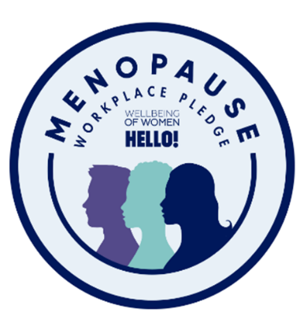**Let’s Talk Menopause!**

At Walsall College women make up **66%** of our workforce and **36%** are aged 50 or over. This means women are and will be affected by symptoms of their menopause during their daily activities.

Walsall College has signed the Menopause Workplace Pledge & takes positive action to ensure anyone going through the menopause is supported.

As part of our commitment we want to: actively support those directly affected by the menopause; Talk openly, positively & respectfully about the menopause; Recognise it affects our staff & provide support. We hold regular Menopause Meet Ups and we actively encourage anyone to attend.

**Walsall College Conversation Teams – Lets Connect!**

We want Walsall College to be and feel a safe place to be. A place where you can be your true self and where there is support & information available. We want to remove the stigmas of some experiences and make them part of everyday conversations & advance how we work together.

This year we have introduced opportunities for informal networks and support for groups with similar experiences. These are intended to be open, respectful & enabling spaces.

This has included the **Menopause Meet Up** and also a **Wellbeing Champion Group**. We intend to build on these groups and expand these conversation teams with the intent of progressing the employer voice and a culture of inclusion.

**Flexible Working**

As part of the College’s commitment to providing a positive working environment, the College endeavour to support employees in achieving an appropriate work-life balance. Last academic year, the College have supported **28** members of staff with flexible working requests.

Clearer guidelines on Ways of Working are also in place which provide further clarity on how we are currently able to operate and support more flexible practices for staff. We will further explore and consider ways of working this academic year.



Walsall College is an accredited member of the Tommy's Pregnancy at Work scheme which has been designed to assist organisations with the tools they need to provide the best level of support for pregnant employees and their managers.

**17** employees took maternity leave during the year 2020/21. **5** employees took paternity leave. Employees on maternity leave are supported with enhanced maternity leave pay provisions.

**Accessibility**

During the last year work has taken place to ensure that information, activities and resources are more accessible**.** Examples of where events have been made accessible and inclusive include interpreters at all staff conference events. Training events have been made accessible in different formats to allow a more inclusive approach including the use of subtitling and accessible formats.



**Mental Health First Aid Team**

Walsall College now has 17 members of staff that are trained as Mental Health First Aiders. The MHFA Team are trained with the skills, knowledge and understanding of first aid for mental health and how to effectively support staff experiencing distress

**Health Cash Plan**

We also offer eligible staff the benefit; SimplyHealth, which aims to keep our workforce healthy while minimising the additional worry about cost. Staff are able to claim back a proportion of the cost of treatment (i.e. dental, optical, prescriptions, vaccinations and counselling) from SimplyHealth. Staff can also access 24/7 GP appointments and an Employee Assistance Programme (EAP) which includes counselling telephone services and cover for up to four children (under the age of 18).

**Able Futures**

Walsall College supports employees who are experiencing stress, anxiety or depression including issues relating to money or finances to access longer term programmes of support via Able Futures.

**DATA ANALYSIS AND COMMENTARY**

The below table gives a summary overview of equality characteristics compared to local and national data.



The AoC Workforce Survey data (2020/21) shows in the sector the breakdown of gender is

64% female, 36% male. The sector continues to employ a higher % of females. Walsall College is slightly higher than the sector average. This survey reports staff recorded as LGBTQ+ as 3%. The Further Education Workforce Data for England, 2018/19 SIR data shows that staff with a declared disability average in the sector was 10%. Walsall College has slightly higher representation in these characteristics than the sector data reporting.

We have continued to consider the way in which we look at and report on data. This includes continuing to look at equality characteristics at different job levels to inform a wider view and any appropriate actions. When looking at the staffing profile this report has also reviewed ethnicity by the different ethnic groups and not by the wider term of BAME, which has been previously utilised in reporting. This is intended to provide opportunity for a further transparency and a different perspective in understanding the staffing profile and the reporting has been aligned to the specific ethnic classifications of the Census. We have used the ONS binary definition of white combined compared with other ethnic categories as the ethnicity categorisation for core headline statistics only.

**Distribution at Management Levels**

The below table shows distribution by characteristic at management level. Operational Management includes delivery management roles and business support managers. The Senior Management Group is the SMT group as outlined in the College organisational structure and does not include the senior leadership roles. The Senior Leadership group is also reported below as a separate group and includes senior post holders and senior direct reports and the Head of Governance.

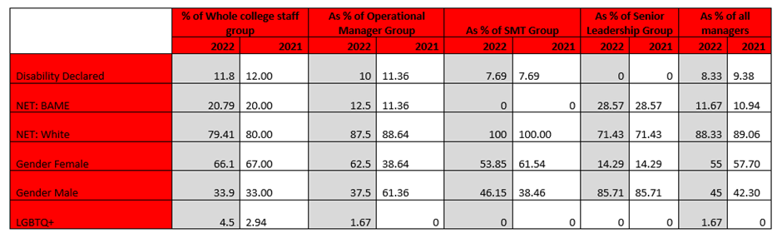

The below chart looks at distribution of managers by ethnic group categories:

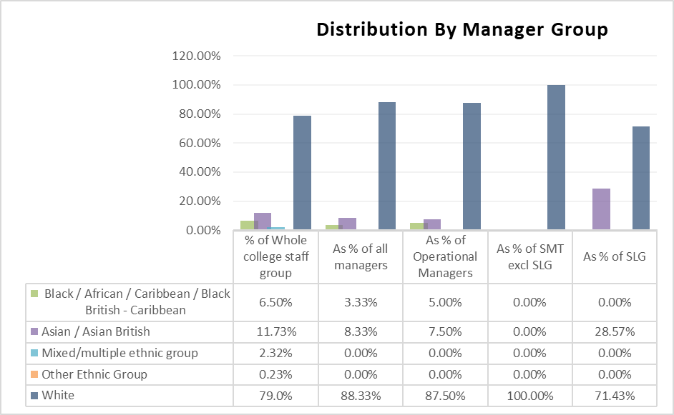

When considering the management distribution this shows a small increase in the NET: BAME representation of all staff in the % of managers at operational managers level. The representation at more senior levels remains the same. This shows that whilst staff in ethnic minority categories represent 21% of all staff they represent 11.67% of all managers.

Females represent 67% of the College workforce. This is not reflected in the management levels and this is more evident at the senior level. Whilst LGBTQ+ representation is slightly higher than the national average within the College workforce, this is not represented within the management levels.

Please see appendix 1 for the detail of the current workforce profile. This is based on a 3-year comparison period based on academic years.

The **staff gender** profile shows a slight decrease in the number of females compared, in particular, with the previous year. As outlined earlier, the sector continues to employ a higher % of females.

In relation to **staff disability**, there has been a slight increase in declared disabilities from 11.3% to 11.8%.

The **ethnicity** profile has not significantly changed. The number of staff in ethnic minority categories has shown a slight increase (now at 21%) from previous years. Although there has been an increase in the staffing ethnicity profile for ethnic minorities and it is higher than the national profile, the representation of these groups is lower than the Walsall and West Midlands data. The College has a seen a reduction in white representation when compared against the national profile, which shows over 81% being “white British” or “white other” but is higher than both the Walsall and West Midlands demographic.

The **age** profile shows the biggest increase within the 60+ category with 14.2% of staff within this age range, an increase of 2.49%. The age range 40-44 has also seen a small increase. In other age ranges there has been a small decrease. has increased by 1.5% for those within the 55-59 age group and staff aged 60+ has increased by nearly 1%.

In relation to the **sexual orientation** of staff, the College has remained successful in recording this information (3.8% of staff prefer not to say which has remained the same on the previous year).

**OUR OBJECTIVES**

The EDI commitment framework outlines a commitment to our objectives under the 5 C’s**:** Culture**,** CPD**,** Curriculum**,** Connected, Challenge**:** As an organisation the following represents our commitments and aims:

|  |  |  |
| --- | --- | --- |
| EDI Commitment | Our Aim | Objective |
| Culture | Drive the development & advancement of a more inclusive culture | Proactively take steps to address imbalances in the representation of staff with particular focus at management levels. |
| Culture | Be attractive to a diverse range of talented people. | Develop & Engage a diverse staff population which reflects and meets the needs of the students and the communities the College serves. |
| Challenge | Challenge Discrimination | Promote a culture of mutual respect, tolerance and continue to adopt a zero-tolerance approach to discrimination, harassment, bullying and victimisation and foster a culture of respect. |
| Connected | Actively Consider EDI in practical ways in all that we do so others can readily see the difference it makes. | Maximise opportunities to develop understanding, and celebration of equality, diversity and inclusion and promote a diverse culture |
| Connected | Progress and strengthen the links between the equality and wellbeing agendas | Champion wellbeing inclusion and work to ensure that wellbeing is seen as a priority for all and demonstrated in our policies and practices |
| CPD | Accelerate the development of diverse talent and future leaders | Ensure that staff at all levels have access to relevant training, tools and personal agency to contribute to positive culture change at all levels of the organisation. |

**OBJECTIVES REVIEW**

|  |  |  |  |
| --- | --- | --- | --- |
| EDI Commitment | Our Aim | Objective | Update |
| Culture | Drive the development & advancement of a more inclusive culture | Proactively take steps to address imbalances in the representation of staff with particular focus at management levels. | Ethnicity reporting data is being reviewed for the year 2021/22 with intention to be produced in line with the gender pay reporting requirements.  Developed mechanisms to provide a project-based approach to opportunities within the College. Offer paid additional responsibility opportunities for delivery staff across the College to be involved in developing staff. It is intended this will:   * Offer opportunities for a broader group of staff with different experience/skill set to be part of the WFD delivery whilst simultaneously upskilling and providing opportunities /development for those staff which contributes to succession planning. * Broader group to support EDI intent to broaden staff involvement opportunities and different voices/perspectives   New appointments in the last 12 months have shown an increase in the percentage of new starters from ethnic minority categories. 12% - Black/African/Caribbean/Black British – Caribbean, 17% Asian/Asian British, 4% Mixed/Multiple Ethnic and 67% White. |
| Culture | Be attractive to a diverse range of talented people. | Develop & Engage a diverse staff population which reflects and meets the needs of the students and the communities the College serves. | The recruitment website is being reviewed to provide more relevant information to support potential applicants in who we are and what we expect and to showcase Walsall College to be an attractive workplace and a recent campaign included examples of staff and students at the College.  Different recruitment practices have been implemented including recruitment open events e.g. learning mentor recruitment event took place which supported potential candidates to speak to current staff and managers and understand better the role and the application processes.  We continue to utilise task-based scenarios which give opportunity to demonstrate relevant work skilled as part of interview processes.  Developed a candidate information pack for vacancies to reflect culture and values of Walsall College as a clear message in our recruitment processes.    Introduced examples of widening participation of staff within recruitment processes e.g. involved staff representatives from different areas of the function in interview process. Students continue to be involved in delivery role.  Tasks undertaken as part of recruitment processes are being reviewed to include more role relevant tasks. |
| Challenge | Challenge Discrimination | Promote a culture of mutual respect, tolerance and continue to adopt a zero-tolerance approach to discrimination, harassment, bullying and victimisation and foster a culture of respect. | Communicated employee wellbeing awareness and campaigns.  Examples include Men’s Health, This is Me, National Conversation Week, Stress Awareness Week, International Women’s Day.  The disciplinary process has been amended to include a broader panel.  Staff interest groups – To advance awareness and realise our objectives, the College has started work to establish conversation teams and interest groups including the Wellbeing Champions & the Menopause Group. The Menopause Awareness training has been introduced 74% of staff have completed this training. |
| Connected | Actively Consider EDI in practical ways in all that we do so others can readily see the difference it makes. | Maximise opportunities to  develop understanding, and celebration of equality, diversity and inclusion and promote a diverse culture | Work in this area is developing and it is intended a clearer plan of communication will be implemented for the beginning of the next academic year.  This academic year we introduced the Menopause Café and have had successful attendance at all sessions & positive feedback from attendees.  Considerations will be given to the developing of the ‘Conversation Teams’ to include other important areas.    Themed focus meetings will be planned to discuss and involve staff with opportunity to input into key priorities and themes.  The College has signed up to be part of the Black Leadership Group. This will form part of the College’s wider approach to EDIB. Initial meetings are arranged to develop and scope the plan for introducing this scheme in 2022/23.  E & D training remains an ongoing requirement for both new starters and existing staff. Current completion of this training is 98%. Training is discussed at the cycle of SMT meetings and also within performance management support meetings with individual operational managers.  Additional training has been identified for all staff – Unconscious bias and this will be added into the mandatory training for staff. |
| Connected | Progress and strengthen the links between the equality and wellbeing agendas | Champion wellbeing inclusion and work to ensure that wellbeing is seen as a priority for all and demonstrated in our policies and practices | Progress is being made and this includes the recent introduction of wellbeing champions. There is a group of 12 wellbeing champions (including the HR leads).  This group has representation from different staff groups i.e. management, lecturer, business support, gender, ethnicity.  Mental health awareness training has been delivered to a group of managers and there is delivery plan for next academic year to deliver this training to all managers with a group of managers receiving this training every half term.  Work is ongoing for the College to achieve accreditation via the Thrive at Work wellbeing accreditation. |
| CPD | Accelerate the development of diverse talent and future leaders | Ensure that staff at all levels have access to relevant training, tools and personal agency to contribute to positive culture change at all levels of the organisation. | Induction and orientation processes have been improved.  The induction programme for new teaching and vocational coach staff has been introduced. This Professional Formation Programme for new teaching staff and Routes to Qualification path for unqualified staff is intended to better support staff new to their roles. This is specifically designed for those staff who may not have traditionally considered teaching and will move into the sector from industry. |

**KEY PRIORITIES AND ACTIONS**

We will continue to focus on the objectives and aims outlined above. As part of those commitments we will:

**APPENDIX 1 - OUR STAFF – SUMMARY OF WORKFORCE DATA**

The data below shows the workforce profile by characteristics over a 3-year comparison period based on academic years.

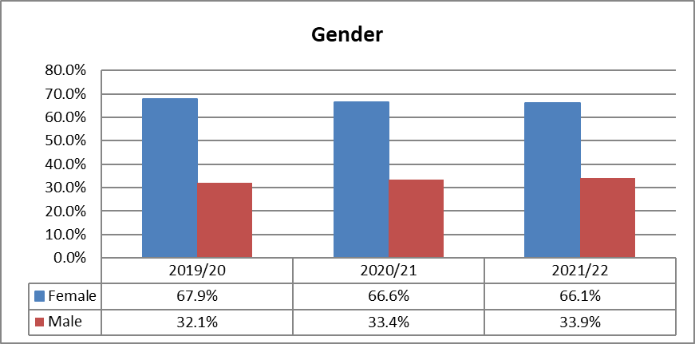

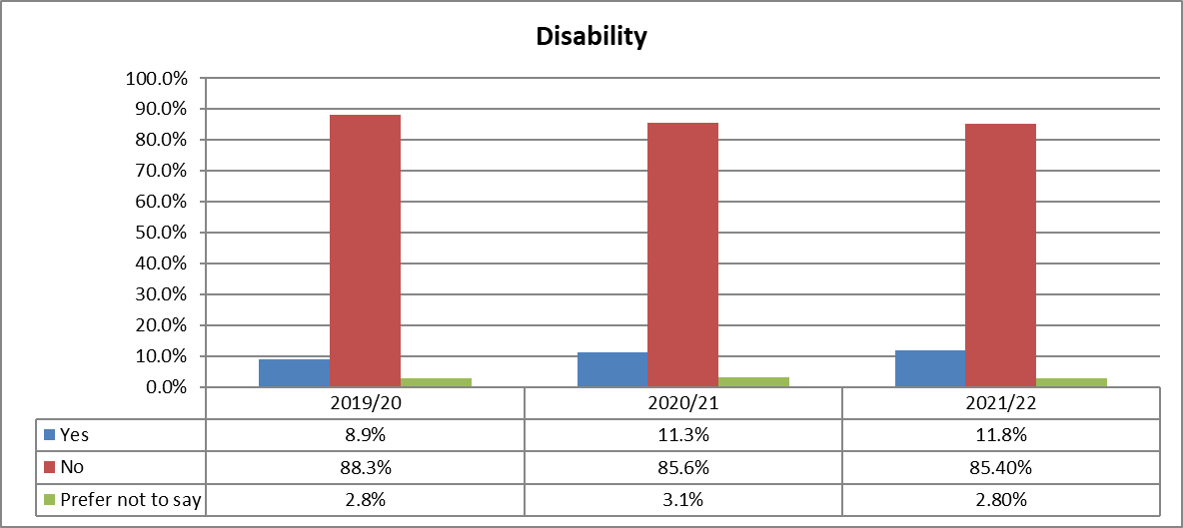

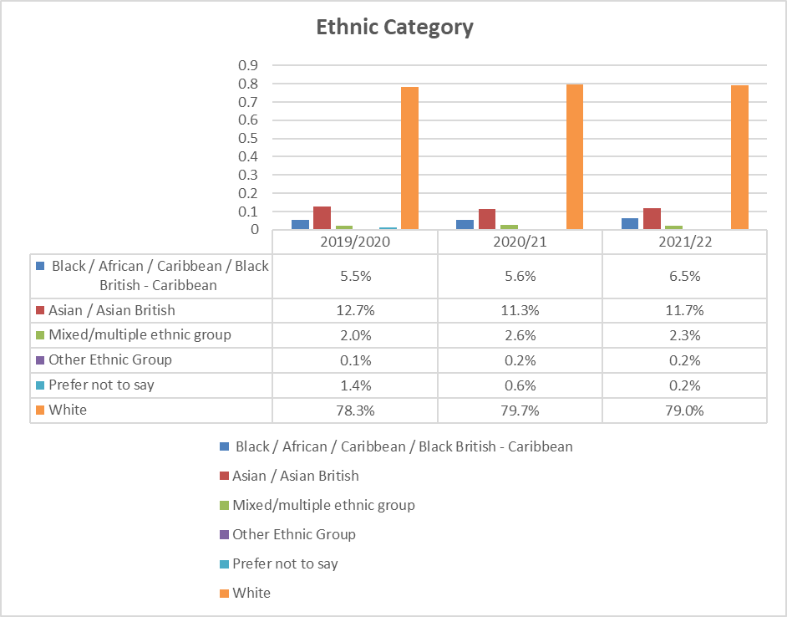

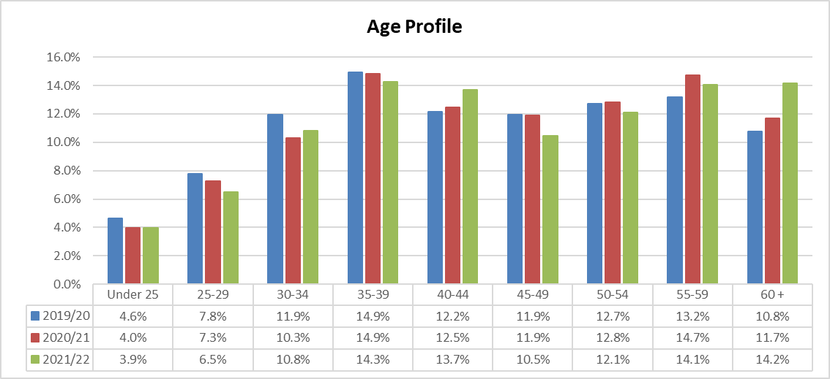

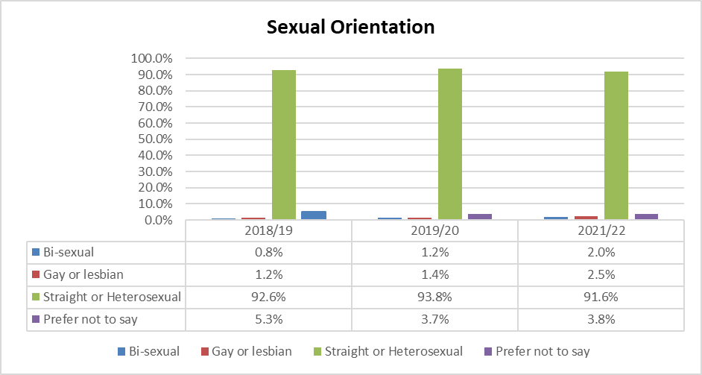

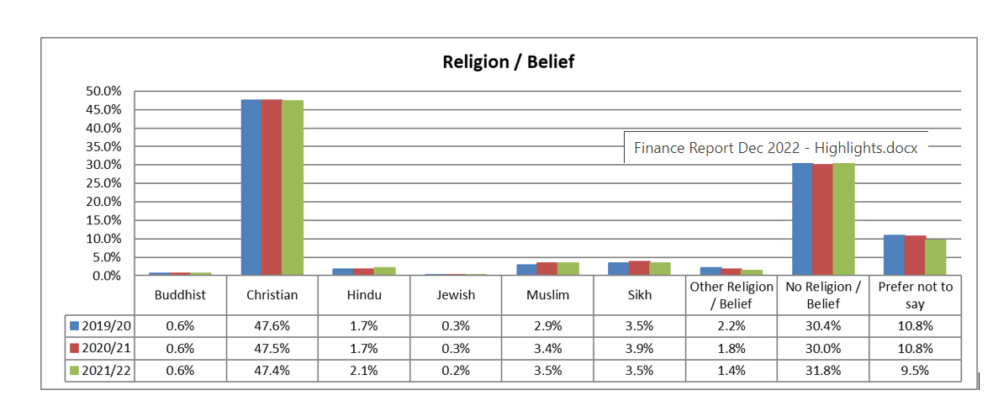

**RECRUITMENT DATA** – The data below for the academic year 2021/22 shows an overview of the recruitment process to include completed applications received, shortlisted, interviewed and offered candidates by characteristic group.

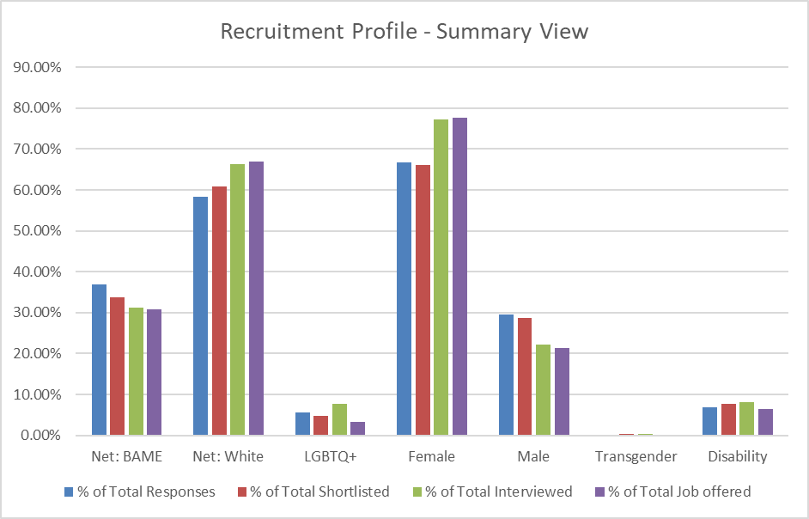

Across the reported protected characteristics there is a decline in the % of total responses received to the % of job offered except the females and also white ethnicity categories which show a higher %. The table below looks at ethnicity by group and there are variances which show that the % of Asian / Asian British and white shows an increase in candidates from the interviewed to the appointed categories.

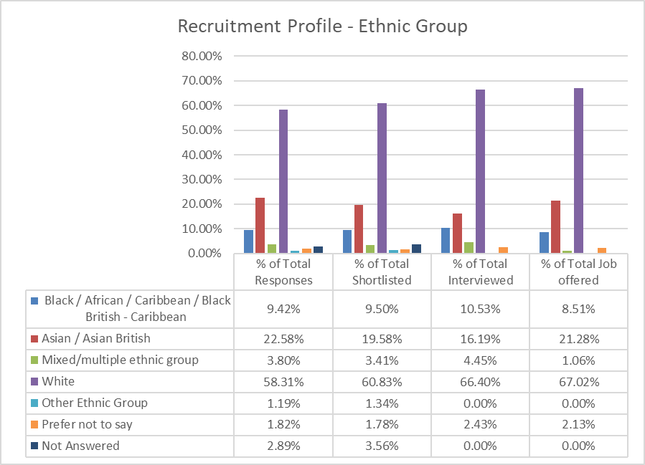

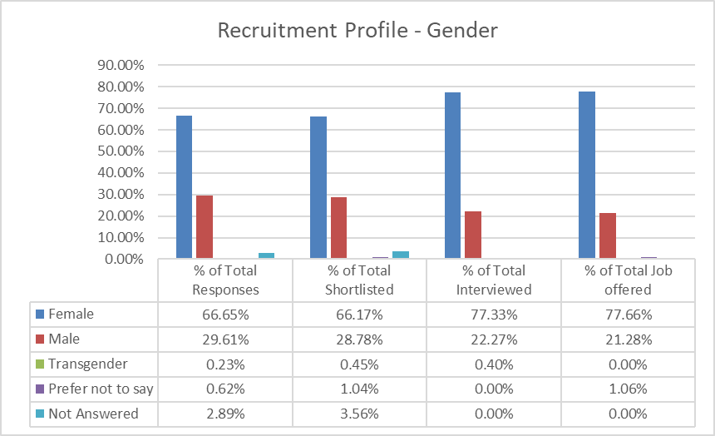

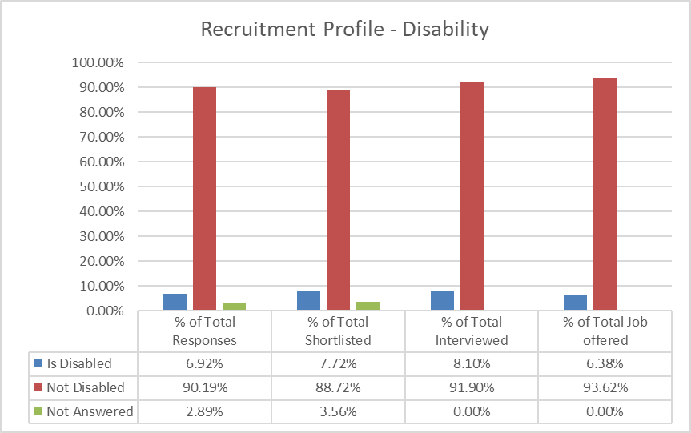

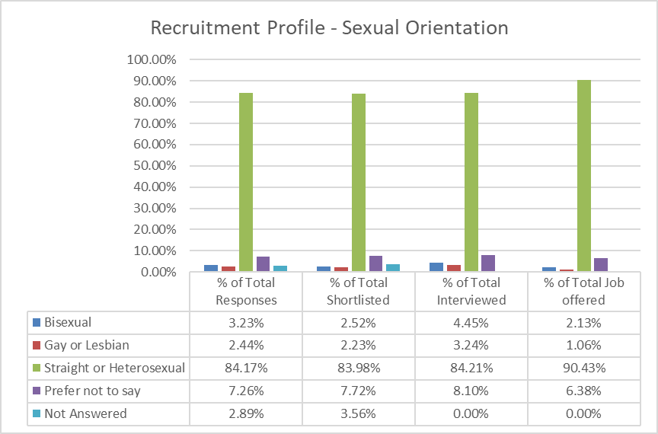

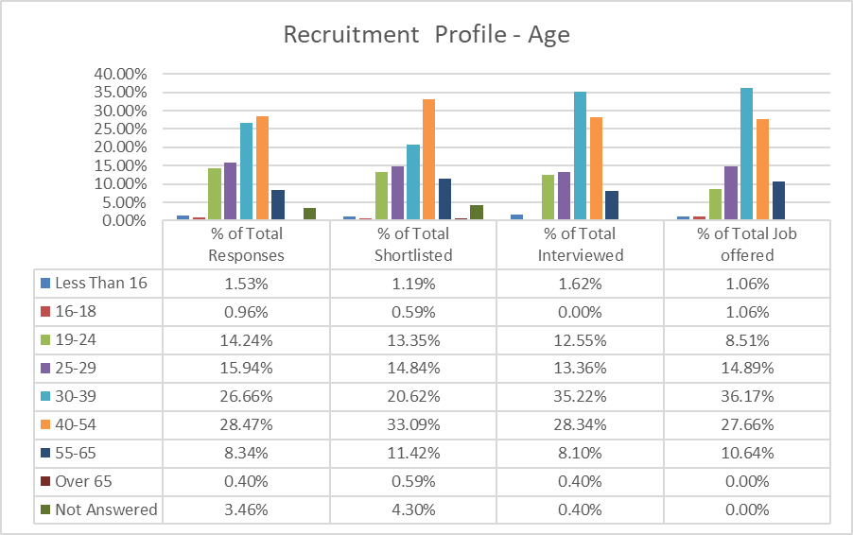

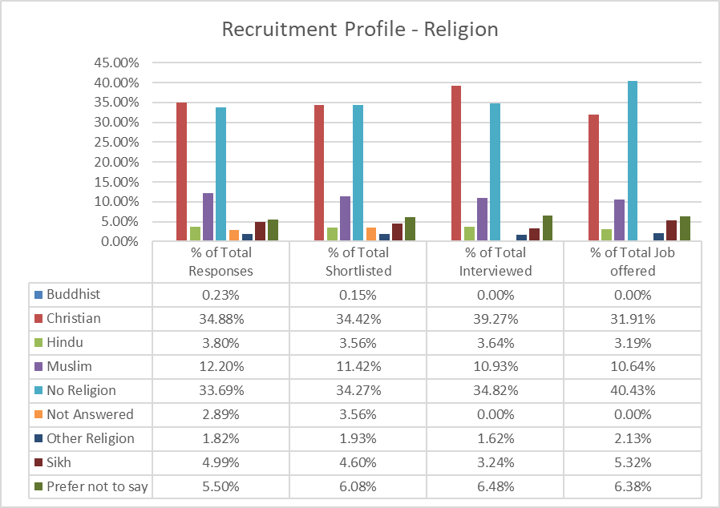

Our current recruitment practices have well established aspects to remove potential for bias including multiple panel members who independently score candidates, anonymous shortlisting with personal details removed, clear scoring criteria, work relevant questions and/or skills tasks that give candidates opportunity to demonstrate their skills, scoring individual questions. All managers who undertake interviewing are also required to complete Safer Recruitment Training & panels must have at least one Safer Recruitment Trained member. 90% of managers have current training.

